


Faculty of Computers & Benha University
Artificial Intelligence

Alzheimer’s Detection with Generative AI
Artificial intelligence, department
Team members
- Ahmed Ashraf Ahmed Alsayed (Leader)
- Ahmed Hussien Shokry Mohammed
- Ahmed Elsayed Ahmed Hassan
- Ahmed Elsayed Mahmoud Arafat
- Abdelrahman Abdo Hassan Ahmed
- Hani Yasser ElMetwaly Sorour Ahmed
- Radwa Mohamed Said Abd El- Shafi
- Shrouk Salama Mahmoud Mohamed
- Nada Adel Ismael Hussainen Shahin
Under Supervision of
Dr. Sara Sweidan
Eng. Sahar Mohamed

بِسْمِ اللَّهِ الرَّحْمَـٰنِ الرَّحِيم
" وَيَسْأَلُونَكَ عَنِ الرُّوحِ قُلِ الرُّوحُ مِنْ أَمْرِ رَبِّي وَمَا أُوتِيتُمْ مِنَ الْعِلْمِ إِلَّا قَلِيلًا "
صدق الله العظيم

Acknowledgment
The success of any project will not happen without the help of many people around us. First, we thank God for giving us the ability to complete our project, we thank our family, friends, doctors, and instructors that help us to complete the project successfully, we want to thank Specially Dr. Sara Swidan for his encouragement, guidance, patience, and his advice for us that have helped us to help us to achieve the success in our project.

In addition, many thanks go to Eng. Sahar Mohamed for his inspirational thoughts, valuable guidance, and assistance throughout this work and for their patience. Finally, we are very grateful to the many people who helped us with contributions to complete this project. , We thank every person in Banha Faculty of Computer and artificial intelligence who may have helped in the tiniest ways possible in this project as well as along the duration of the educational time in college., We deeply thank our parents and siblings for the support and encouragement along the four years of college time.

Table Of Contents
Chapter 1→ Introduction & Background 8
1. Introduction 8
1.1 Background 9
2. Problem Definition 12
2.1 The Importance of This Problem 12
2.2 The Current Solutions 12
2.3 Project Objectives 14
3. Scope Initiation 15
4. Summary 16
Chapter 2 → Analysis and Design 17
1. Introduction 17
2. User and System Requirements 19
2.1 User Requirements 19
2.2 System Requirements 19
3. System Design 22
3.1 System Architecture 22
3.2 Use Cases Diagram 23
3.3 Activity Diagrams 24
3.4 Class Diagrams 27
3.5 Sequence Diagrams 28
3.6 Gantt chart 30
3.7 Data Flow Diagram (DFD) 31
3.8 State Diagram 33
3.9 Entity Relationship Diagram (ERD) 33
4. Technologies and Tools 35
5. Summary 35
Chapter 3 → Alzheimer’s Model (4 class of Images) Analysis & Visualization 36
1. Libraries 36
2. Dataset Gathering 37
3. Read Data 37
4. Visualization & Analysis of Dataset (data preprocessing) 39
4.1 Data preprocessing 39
4.2 Visualization 39
4.3 Analyzing a dataset 39
4.4 Split Data 40
4.5 Data Augmentation 43
5. Model training 46
5.1 CNN 48
5.2 VGG16 62
5.3 DenseNet201 70
5.4 ResNet152V2 77
5.5 MobileNetV2 84
5.6 Summary 91

List Of Figure
Figure (1) System Architecture 22
Figure (2) Use Cases Diagram 23
Figure (3) Login Diagram 24
Figure (4) User Diagram 25
Figure (5) Doctor Diagram 26
Figure (6) Class Diagrams 27
Figure (7) User Sequence Diagram 28
Figure (8) Doctor Sequence Diagram 29
Figure (9) Gantt chart 30
Figure (10) Context Diagram (Level 0) 31
Figure (11) DFD (Level 1) 32
Figure (12) State Diagram 33
Figure (13) ERD 34
Figure (14) Machine Learning Process 36
Figure (15) Train Data 41
Figure (16) Test Data 42
Figure (17) Validation Data 43
Figure (18) Data Visualization 45
Figure (19) CNN Model 48
Figure (20) CNN Model Scratch 53
Figure (21) CNN Evaluation 58
Figure (22) CNN Prediction 60
Figure (23) CNN Confusion Matrix 61
Figure (24) VGG16 Model 62
Figure (25) VGG16 Model Scratch 63
Figure (26) VGG16 Evaluation 66
Figure (27) VGG16 Prediction 68
Figure (28) VGG16 Confusion Matrix 69
Figure (29) DenseNet201 Model 70
Figure (30) DenseNet201 Model Scratch 71
Figure (31) DenseNet201 Evaluation 74
Figure (32) DenseNet201 Prediction 75
Figure (33) DenseNet201 Confusion Matrix 76
Figure (34) ResNet152V2 Model 77
Figure (35) ResNet152V2 Model Scratch 78
Figure (36) ResNet152V2 Evaluation 81
Figure (37) ResNet152V2 Prediction 82
Figure (38) ResNet152V2 Confusion Matrix 83
Figure (39) MobileNetV2 Model 84
Figure (40) Model Scratch 85
Figure (41) MobileNetV2 Evaluation 88
Figure (42) MobileNetV2 Prediction 89
Figure (43) MobileNetV2 Confusion Matrix 90
Figure (44) Models Summary 91

Chapter 1→ Introduction & Background
- Introduction
Alzheimer's disease (AD), named after the German psychiatrist and neuropathologist Alois Alzheimer who first described it in 1906, is a progressive neurodegenerative disorder characterized by cognitive decline and memory impairment. It is the most common cause of dementia, contributing to approximately 60-70% of all cases.
The disease typically begins with subtle memory problems, such as difficulty remembering recent events or conversations, and progresses over time, affecting various cognitive functions including language, reasoning, and judgment. As the condition advances, individuals may experience disorientation, mood swings, changes in behavior, and difficulty performing everyday tasks. In the later stages, individuals may lose the ability to recognize loved ones, communicate effectively, and care for themselves.
The underlying cause of Alzheimer's disease is not fully understood, but it is believed to involve a complex interplay of genetic, environmental, and lifestyle factors. Pathologically, Alzheimer's is characterized by the accumulation of abnormal protein deposits in the brain, namely beta-amyloid plaques and tau tangles, which lead to the destruction of nerve cells and disruption of neural communication.
Currently, there is no cure for Alzheimer's disease, and available treatments aim to alleviate symptoms and slow down disease progression. Research into potential treatments and preventive strategies continues, driven by the urgent need to address the growing impact of Alzheimer's on individuals, families, and society as a whole.

1.1 Background
A major cause of Alzheimer's disease has not yet been identified, but there are some factors that increase the risk of developing it, including the following:
- Age, where the risk of developing the disease increases with age, as most people with this disease are over 65 years old.
- Family history, the risk of Alzheimer's increases if a person's family member has the disease.
- Genes, where some genes have been linked to causing Alzheimer's disease.
- Other factors, such as head injuries, heart health and related diseases, increase the risk of Alzheimer's disease in people with health conditions that cause damage to the heart or blood vessels, such as strokes, high blood pressure, diabetes, and others.
The course of the disease is divided into three stages, with a progressive pattern of cognitive and functional impairment.
Early stage: Mild symptoms.
The early stage of Alzheimer's disease begins with mild symptoms such as memory loss and mental confusion. During this period, a person may have difficulty remembering newly acquired information, and may make mistakes in puzzles and games in which they were previously successful. Sometimes they may lose some objects in their environment or at home and have difficulty finding them.
These symptoms, which do not affect a person's daily life, are usually noticed by their inner circle. At this stage, the person can still do their job in daily life and live a normal life. However, more severe symptoms may appear if the disease is not diagnosed during this period. Family doctors or neurologists are usually the first to be visited because of mild symptoms.
The diagnosis of the disease in the early stage is usually made using a series of tests and imaging methods. These tests include cognitive tests, neuropsychological tests, and imaging tests such as magnetic resonance imaging (MRI).
Middle stage: Symptoms that affect daily life.
The middle stage of Alzheimer's disease is characterized by memory loss and severe loss of cognitive abilities. At this stage, symptoms that affect a person's daily life begin to appear and they may lose their independence. A person may forget the names of people they know, have trouble remembering places in their immediate surroundings, and have difficulty performing simple tasks they've done before.
Cognitive and emotional difficulties in a person increase in the middle stage. A person may have serious difficulties understanding and communication and may have difficulty understanding speech. Changes in personality and behavior can be observed due to changes occurring in a person's mind. For example, a person may be moody, irritable, or anxious.
In the intermediate stage, the disease is diagnosed and medical support is sought. Treatment is carried out to slow the progression of the disease and a specific care plan is prepared for the patient. Patients during this stage need more help and their caregivers need a plan as well.
Advanced stage: the condition that needs care.
The advanced stage of Alzheimer's disease leads to a person being completely dependent on others. At this stage, he develops severe symptoms such as severe memory loss, language impairment, and walking difficulties. A person becomes having difficulty performing activities of daily living and needs full-time care and support.
As the symptoms of the disease increase in the advanced stage, personal and behavioral changes increase significantly. Patients may become more anxious or afraid. Speech and communication skills may also be affected, and the patient may be completely dependent on caregivers for daily activities and personal care.
Because the patient is now completely dependent on others, home care may not be possible, and the patient may need to be transferred to a specialized care center for care. These care centers provide specialized services provided by healthcare professionals, specialists in daily activities and personal care of patients.
As of my last update in January 2022, global statistics for Alzheimer's disease may vary based on different sources and methodologies used for data collection. However, I can provide some general information:
Prevalence: Alzheimer's disease and other dementias are significant public health concerns globally, with millions of people affected. According to estimates from the World Health Organization (WHO), there were approximately 50 million people worldwide living with dementia in 2019, with Alzheimer's disease being the most common cause of dementia. This number is expected to increase significantly in the coming years due to aging populations and other factors.
Future Projections: With population aging and increasing life expectancy, the prevalence of Alzheimer's disease is projected to rise substantially in the coming decades. Some projections suggest that the number of people living with dementia worldwide could reach 152 million by 2050 if no effective interventions are implemented to prevent or slow the progression of the disease.

- Problem Definition
Alzheimer's disease entails progressive cognitive decline, memory loss, and daily function impairment, imposing emotional, financial burdens, and global healthcare challenges, necessitating early detection, effective treatment, and support.

2.1 The Importance of This Problem
The problem of Alzheimer's disease is of paramount importance due to its devastating impact on individuals and society. Alzheimer's patients face progressive cognitive decline, impacting memory, reasoning, and daily functioning. As the disease advances, patients require increasing levels of care, often placing strain on families and caregivers. Alzheimer's disease is the leading cause of dementia, affecting millions worldwide. It poses significant challenges to healthcare systems, requiring specialized resources for diagnosis, treatment, and support.
The emotional toll on patients and their loved ones is profound, as cherished memories and relationships fade away. Addressing Alzheimer's is essential for preserving quality of life and dignity for affected individuals. Research into prevention, early detection, and effective treatments is critical to combatting this growing public health crisis. Supporting Alzheimer's patients and their families is crucial for ensuring compassionate care and support throughout the disease journey.

2.2 The Current Solutions
This is a sample of some applications that help Alzheimer's patients:
- Memory Stimulation Apps:
    - My Reef 3D: Interactive game with virtual fish to improve memory.
    - Reminiscence: Displays pictures from the past to stimulate memories.
    - Lumosity: Training games to enhance memory and cognitive skills.
- Communication Apps:
    - Timeless: User-friendly app for remembering events and staying connected with family and friends.
    - Talking Point: Communication platform for Alzheimer's patients and their families.
    - Ava: Writing and speech assistance app to aid communication.
- Daily Assistance Apps:
    - Caregiver Smart: Smart assistant for caregivers of Alzheimer's patients.
    - Medisafe: App to remind patients to take their medication.
    - WanderSafe: GPS tracking system to prevent patients from wandering off.
- Diagnostic Apps:
    - SimBrain: Brain imaging analysis tool for early detection of Alzheimer's signs.
    - Akili Interactive: Interactive games to assess cognitive abilities.
    - Cogito: Digital tests for diagnosing Alzheimer's disease.
- Other Apps:
    - HappyNeuron: Training games to stimulate cognitive functions.
    - BrainHQ: Games and activities to improve memory and focus.
    - Pzizz: Music and soundscapes to enhance sleep.

2.3 Project Objectives
The primary objective of this project is to leverage state-of-the-art Deep Learning methodologies for the purpose of medical image analysis, focusing on the precise detection of Alzheimer's disease. By employing advanced neural network architectures, we aim to develop a robust diagnostic tool capable of accurately identifying the presence of Alzheimer's pathology within medical imaging data.
In addition to the deployment of Deep Learning models, we propose the integration of a Generative model component into our framework. This Generative model serves a dual purpose: firstly, to corroborate the findings of disease detection through the synthesis of supplementary visual data, thus enhancing the reliability of diagnostic outcomes. Secondly, the Generative model serves to mitigate patient anxiety and stress associated with medical examinations by providing personalized, visually coherent representations of diagnostic results.
The utilization of cutting-edge Deep Learning techniques underscores our commitment to achieving high levels of accuracy and reliability in disease detection within medical imaging contexts. Through rigorous model training and validation processes, we endeavor to establish a robust and clinically viable tool for Alzheimer's diagnosis, with the potential for broader applications in medical image analysis.
Furthermore, the incorporation of a Generative model component reflects our holistic approach to addressing not only diagnostic accuracy but also patient-centered care. By prioritizing the reduction of patient stress and anxiety through innovative technological solutions, we aim to enhance the overall patient experience within the realm of medical imaging diagnostics.
The interdisciplinary nature of this project necessitates collaboration between experts in Deep Learning, medical imaging, and healthcare. Through close collaboration and knowledge exchange, we aim to leverage the collective expertise of diverse stakeholders to drive meaningful advancements in Alzheimer's disease detection and patient care.
Our project adheres to the highest standards of ethical conduct and data privacy, ensuring that patient confidentiality and consent are paramount throughout all stages of research and development. By upholding these principles, we demonstrate our commitment to responsible innovation and the well-being of patients and individuals involved in our study.
- Scope Initiation
Our project's scope focuses on assisting individuals aged 50 to 85 who are in the early and middle stages of Alzheimer's disease. With a primary aim to support both patients and healthcare providers, our initiative serves as a crucial assistant to doctors in diagnosing and managing the disease.
Through innovative technologies and tailored interventions, we aim to help patients refresh their memory and enhance cognitive function, thereby improving their quality of life. By targeting this specific demographic, we acknowledge the critical need for early intervention and support in Alzheimer's care.
Our scope encompasses the development of assistive tools and applications that aid healthcare professionals in accurate diagnosis and personalized treatment planning. Additionally, we aim to empower patients by providing them with accessible resources and support systems to navigate their journey with Alzheimer's disease.
By focusing on the early and middle stages of the disease, we aim to intervene at a crucial juncture where timely assistance can significantly impact disease progression and patient outcomes. Through collaborative efforts with medical experts and caregivers, we aspire to optimize care delivery and enhance patient well-being.
Our scope initiation emphasizes a holistic approach to Alzheimer's disease management, encompassing medical, psychological, and social aspects of care. By addressing the needs of both patients and healthcare providers, we aim to foster a supportive ecosystem that promotes early detection, effective intervention, and improved outcomes for individuals living with Alzheimer's disease.
- Summary
Now we have finished the first chapter of our project, which helped us understand and know all the information on which the project is based, starting with a clear and concise introduction to Alzheimer's disease (AD), its progressive nature, and its crippling effects on memory and thought. It emphasizes the significant impact on millions globally, highlighting the lack of a cure and the urgency for solutions.
The chapter acknowledges the existing efforts in supporting patients and caregivers, outlining various applications that assist with memory stimulation, communication, and daily tasks. However, it recognizes the limitations of these solutions and paves the way for our innovative project.
This section introduces our ambitious project utilizing cutting-edge Deep Learning for precise AD detection through medical image analysis. It goes beyond mere diagnosis, incorporating a Generative AI component to create personalized visualizations for patient comfort and understanding.
Our focus isn't solely on technology; it's about people. We target the crucial early and middle stages, empowering both patients and healthcare providers with personalized tools and plans. Collaboration and ethical considerations are paramount as we strive for a holistic approach encompassing medical, psychological, and social aspects of care.

Chapter 2 → Analysis and Design
- Introduction
Analysis is defined as the process of identifying problems and organizing the facts and details of a system. Analysis can also be described as the careful breakdown of a system into its organized components or parts. This process helps you to know the ins and outs of the system. It is important to know what works with what, what makes something work or fail, and what can work independently.
Importance of analysis:
Analysis is important because it provides a means to the solutions in the system through the various tasks involved in performing the analysis graphs. Through these various tasks, which makes it easy to implement the project because it serves as a map of everything that is involved in the project and the overall quality of the system can be easily modified or improved, and the occurrence of errors can be reduced in the end.

There are a set of procedures and steps to create this analysis summarized as follows:
1. Determinations of requirements: We prepare user and system requirements and have 2 types:
    - Functional requirements
    - Non – functional requirements
2. Stack holders: Determine the people who benefit or are interested in the project such as:
- Doctors
- Users (Patients)

3. System Design: It consists of a set of Diagrams that describe the entire project and a working mechanism such as:
- System Architecture
- Use Cases
- Activity Diagram
- Class Diagram
- Sequence Diagrams
- Database Design
4. Application of the system
5. System evaluation (as we will see in next chapter)
6. Modify the system (as we will see in next chapter)

2. User and System Requirements

2.1 User Requirements
User requirements are just what the name implies. They are requirements set by the end user. These requirements express how an application should perform in terms of the functions to be done. User requirements provide information that serves as the basis for further specification and design.
User Requirements
contains a model that detection Alzheimer's disease
contains intelligent chat for Alzheimer's.
Provides a lot of tests besides chatting to diagnose the patient's condition.
Provides a list of histories containing all test results.
Be easy, simple, and understandable for all age groups.
Provide the possibility communicate with a specialized doctor if necessary.

2.2 System Requirements
The requirements that specify criteria that can be used to judge that the system operates as expected.

2.2.1 Functional Requirements
Requirements | Description
User authentication | An application for users to log in and register, either through an email and password combination.
Alzheimer's detection interface | Interface for users for Alzheimer's classification. This should be intuitive and easy to use.
Chat interface | A chat interface for users to communicate with the chatbot. This should be intuitive and easy to use.
Natural Language Processing (NLP) and understanding | A chatbot must be able to understand user input and respond to it in a conversational manner, and chatbot must be able to track the context of a conversation and provide relevant responses.
Personalized recommendations | Based on the user's assessment, the chatbot should be able to provide personalized recommendations for self-care, therapy, and other mental health resources.
Notification system | The system should have a notification system to alert users about scheduled assessments, follow-ups, or important information related to Alzheimer's detection and care.

2.2.2 Non – Functional Requirements
Requirements | Description
Response Time | The system should provide quick responses to user inputs, with a maximum response time of X seconds for both the chat interface and Alzheimer's detection interface.
Usability | for both the generative model and Alzheimer's detection model must be user-friendly and provide a smooth and intuitive experience for users.
Maintainability | for both the generative model and Alzheimer's detection model must be easy to maintain and upgrade as necessary.
Reliability | The application should be reliable and available, so users can access support whenever they need it.
Scalability | Design the system to handle a growing user base by ensuring scalability. The generative and detection models should be scalable to accommodate larger datasets and evolving requirements.
Security | Ensure that all sensitive data, especially health-related information, is encrypted.

3. System Design
It consists of a set of Diagrams that describe the entire project and a working mechanism.

3.1 System Architecture
A system architecture is the Conceptual model that defines the structure, behavior, and more views of a system. An architecture description is a formal description and representation of a system, organized in a way that supports reasoning about the structures and behaviors of the system.
- Diagram in Figure (1) describes the structure of the system and all the functions.
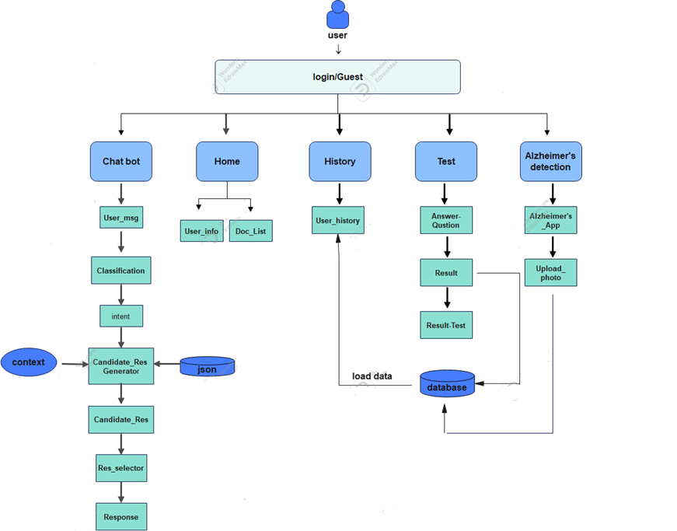
Figure (1) System Architecture

3.2 Use Cases Diagram
The Use Case in Figure (2) contains three actors User, Doctor, and AI Doctor, each actor has some of the process he performs, such as that the User can login and chose a doctor and the talk with the Chabot. And that the Doctor can login and be responsible for choosing the date for patients.

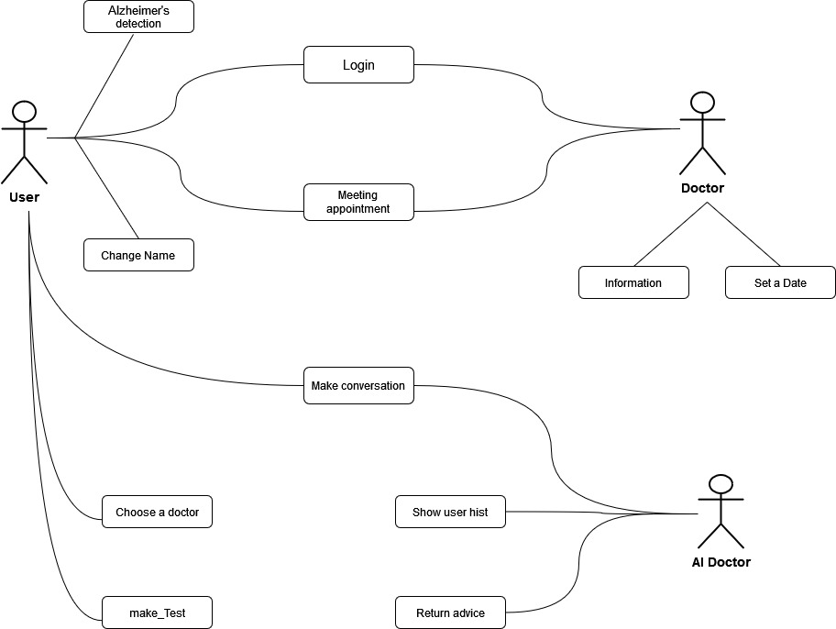
Figure (2) Use Cases Diagram

3.3 Activity Diagrams

The Activity Diagram in Figure (3), Figure (4), and Figure (5) explains the operations that are carried out on each process, and I see the validation, the powers, and how the system will work, In the case of success, one thing is done, and in case of failure, another thing is done.

3.3.1 Login Diagram

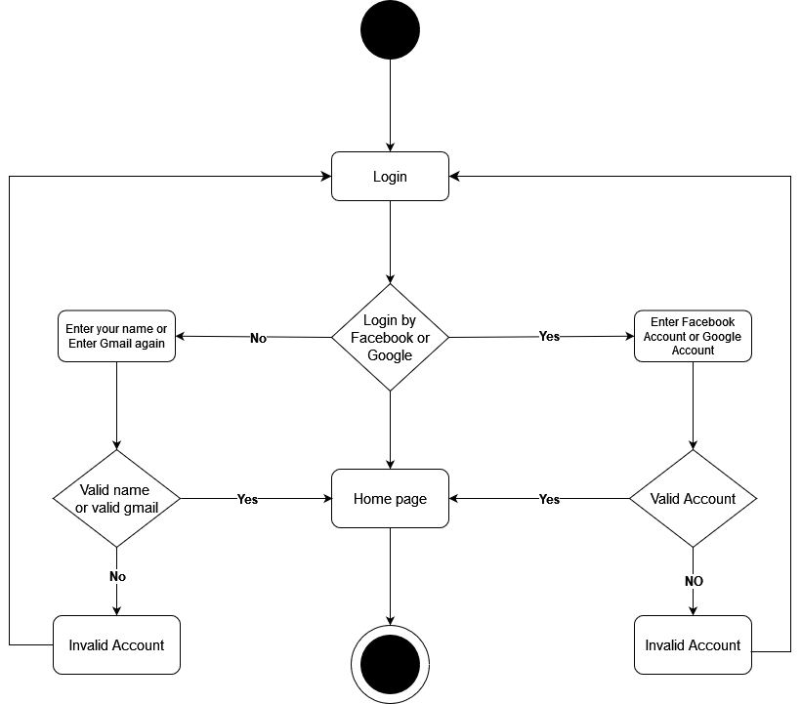
Figure (3) Login Diagram

3.3.2 User Diagram

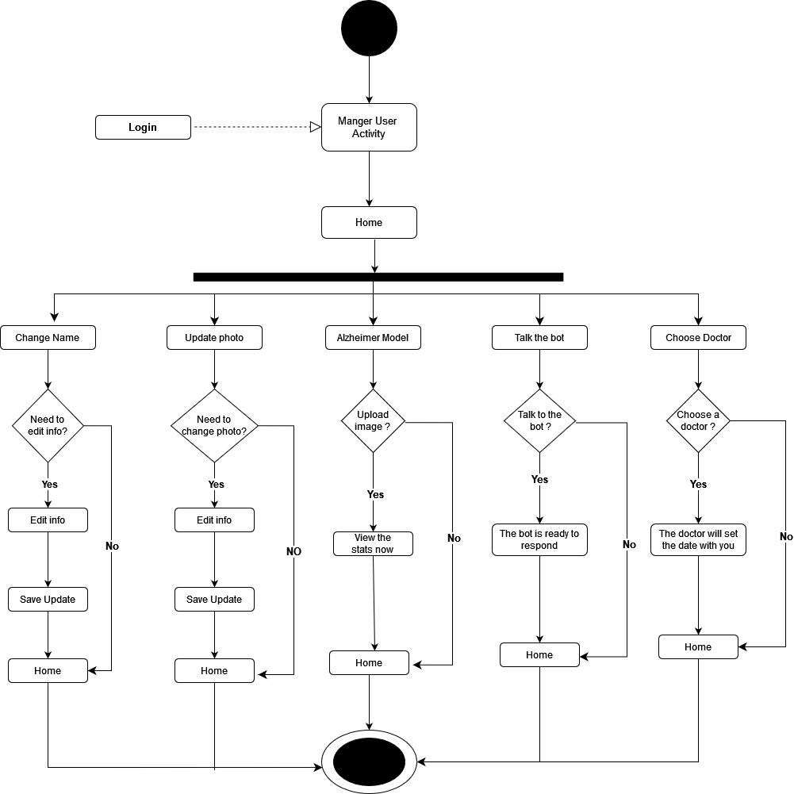
Figure (4) User Diagram

3.3.3 Doctor Diagram
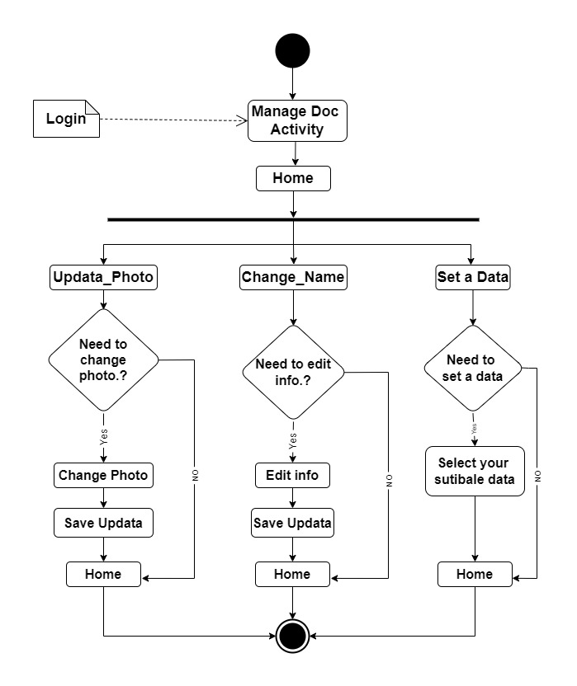
Figure (5) Doctor Diagram

3.4 Class Diagrams

The Class Diagram in Figure (6) is the one that describes the classes that the database, is a type of static structure diagram that describes the structure of a system by showing the system's classes, their attributes, operations (and methods), and the relationships among objects.

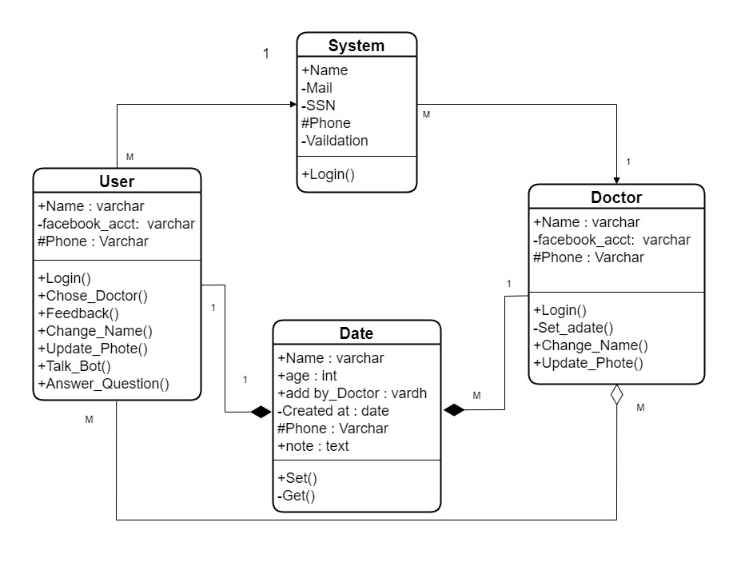Figure (6) Class Diagrams

3.5 Sequence Diagrams
Sequence diagram, in Figure (7), Figure (8), which is that I see processes behind each other for each action process that happens to it, and this will have a complete and comprehensive description of any activity that occurs in the system. They capture the interaction between objects in the context of a collaboration. Sequence Diagrams are time focus and they show the order of the interaction visually by using the vertical axis of the diagram to represent time what messages are sent and when.

3.5.1 User Diagram

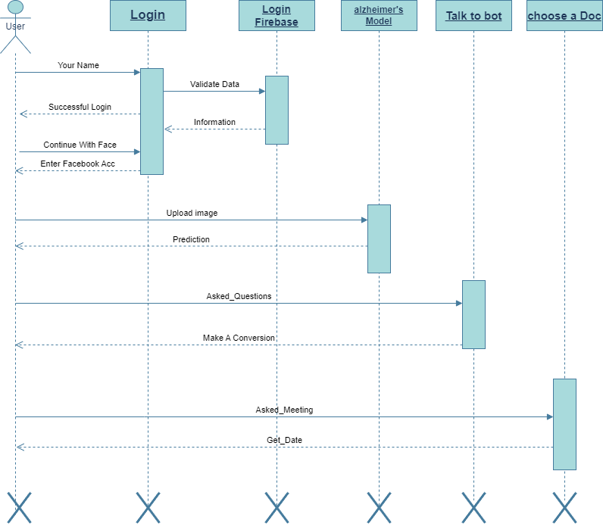
Figure (7) User Sequence Diagram

3.5.2 Doctor Diagram

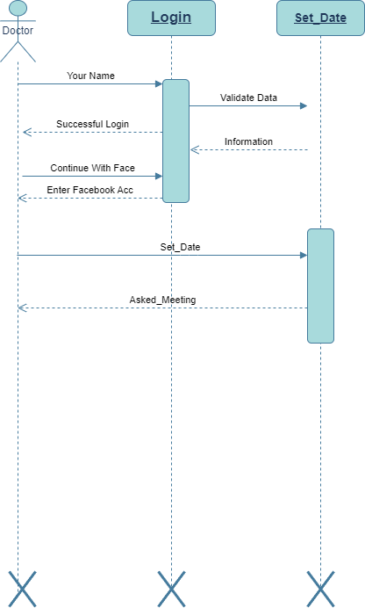
Figure (8) Doctor Sequence Diagram

3.6 Gantt chart
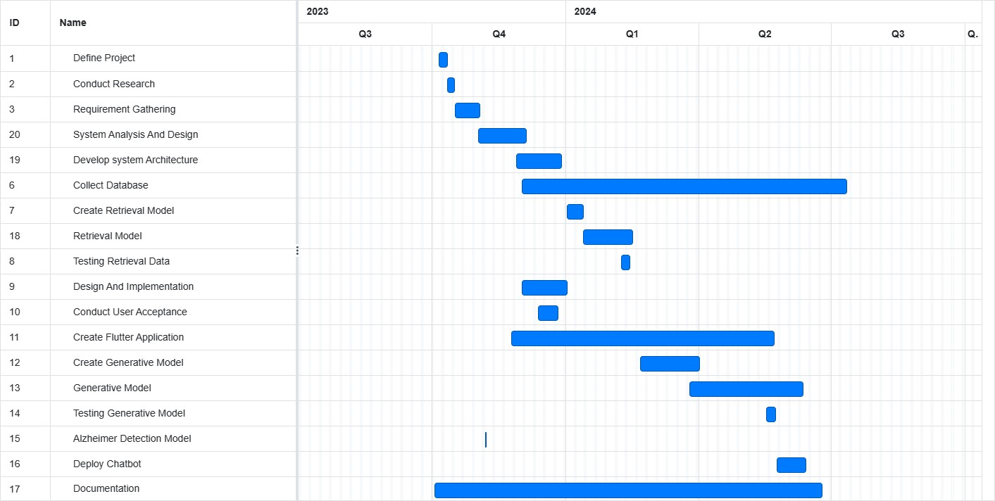
Figure (9) Gantt chart

3.7 Data Flow Diagram (DFD)

Can be divided into logical and physical. The logical data flow diagram describes a flow of data through a system to perform certain functionality of a business. The physical data flow diagram describes the implementation of the logical data flow.

3.7.1 Context Diagram (Level 0)
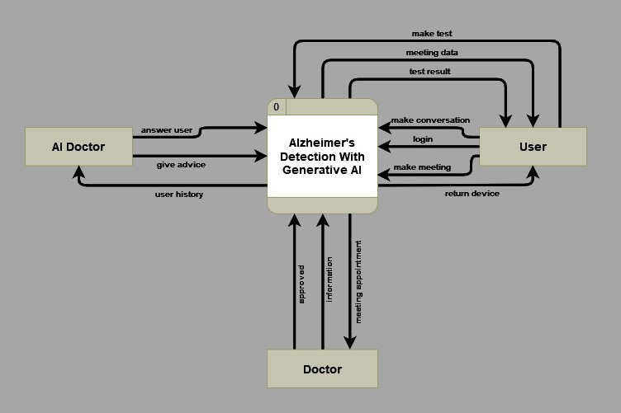
Figure (10) Context Diagram (Level 0)
"Data flow diagrams (DFDs) serve as visual representations depicting the intricate flow of data within a business information system. In the context of an Alzheimer's detection model empowered by generative AI, DFDs outline the processes involved in transferring, analyzing, and interpreting data, from initial input through various stages, ultimately culminating in the identification and reporting of potential markers for Alzheimer's disease."

3.7.2 DFD (Level 1)
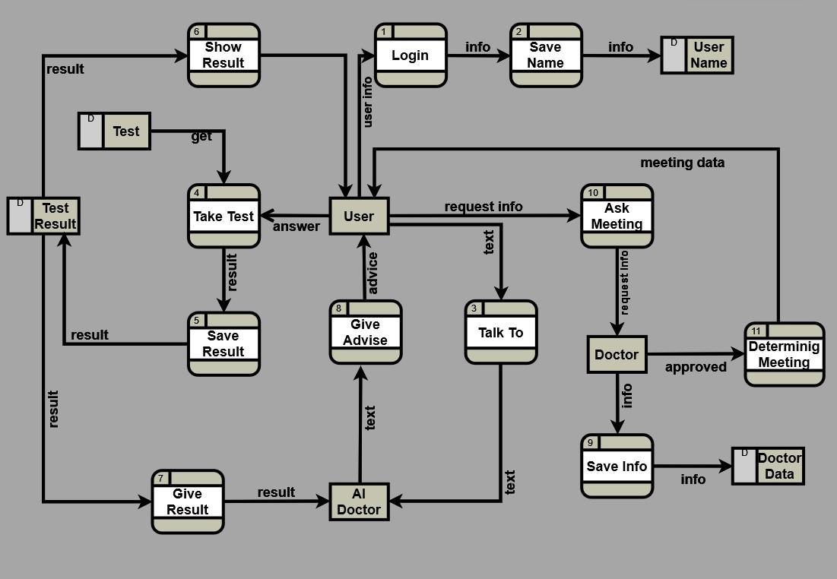
Figure (11) DFD (Level 1)

3.8 State Diagram

State Diagrams in Figure (12) is a type of diagram used in computer science and related fields to describe the behavior of systems. State diagrams require that the system described is composed of a finite number of states; sometimes, this is indeed the case, while at other times this is a reasonable abstraction. Many forms of state diagrams exist, which differ slightly and have different semantics.
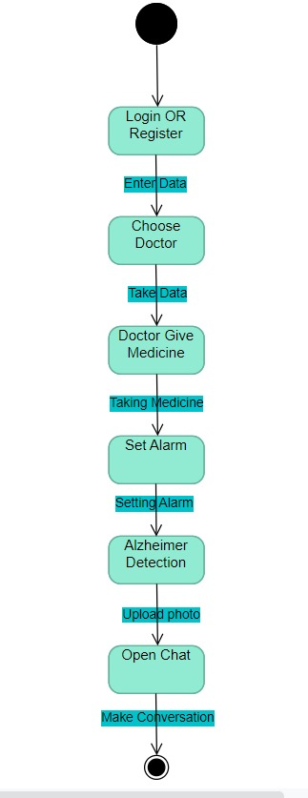
Figure (12) State Diagram

3.9 Entity Relationship Diagram (ERD)
ERD (Entity-Relationship Diagram) in Figure (13) is a visual representation of entities and their relationships to each other. It is used to describe the data and relationships between entities in a database or application. An ERD represents Users, Tests questions, Answer Tests, Topic, and Results entities. These entities have relationships with each other such as a User taking a test question, or a User having many Results. The ERD also shows the attributes and data types of each entity, such as the User's name and email.

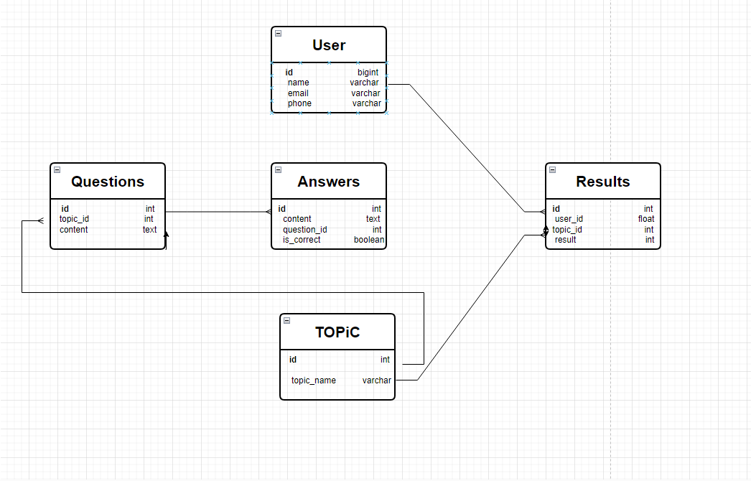
Figure (13) ERD

4. Technologies and Tools
Tools
Programming language (Python)
Machine Learning (ML)
Deep Learning (DL)
Natural Language Processing (NLP)
Natural Language Understanding (NLU)
Mobile Development
Flask
Firebase and local database

5. Summary
In this chapter We talk about the complete analysis of all the functions that the application performs, and this analysis is represented in a set of diagrams that in turn make it easier for us to understand and implement the project and the ease of modification to it. Each diagram is different from the rest and represents the functions and how the application performs them in a sequential manner. We also know who the owners are the interest of that application, which is the doctor, the user, and the enabler of the developer because he has an interest because of the return on him from using the application. One of the most important parts in this chapter is knowing the requirements of this project, which is represented in the required functions that the project or application does not exist except in their presence and non-required functions. Also, we have become fully aware of the requirements of both the user and the system requirements as well.

Chapter 3 → Alzheimer’s Model (4 class of Images) Analysis & Visualization
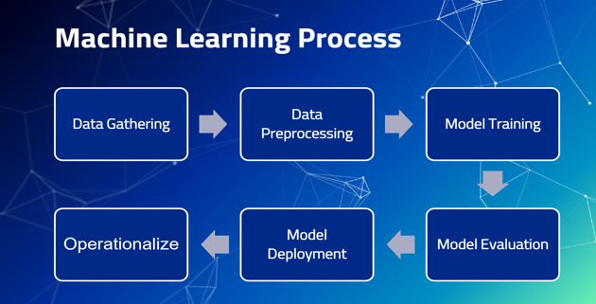
Figure (14) Machine Learning Process

1. Libraries
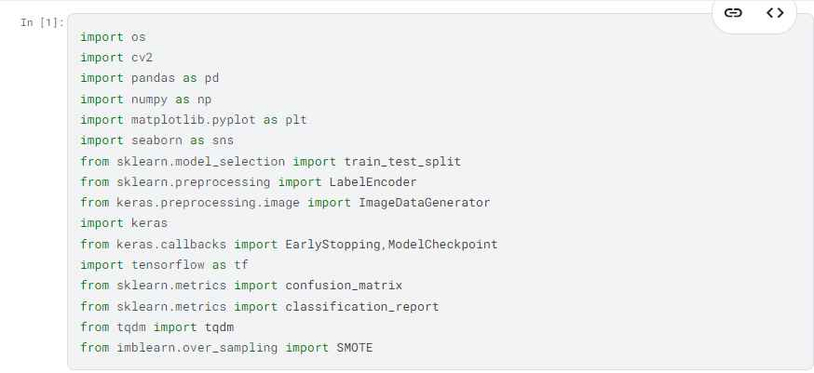

2. Dataset Gathering
-This data show four classes: -
1- Alzheimer’s disease
2- Cognitively normal
3- Early mild cognitive impairment
4- Late mild cognitive impairment
-The data consists of two columns: -
• images
• labels

3. Read Data

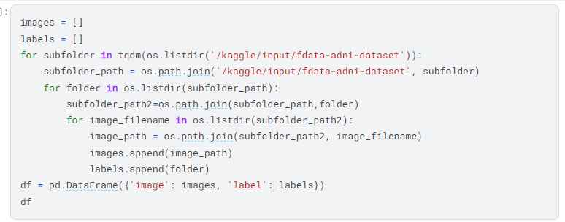

-Show Data Frame: -
A Data Frame is a two-dimensional, tabular data structure commonly used in data analysis and statistics. It is a fundamental concept in programming languages such as Python (with libraries like Pandas), R, and Julia. The Data Frame is designed to organize and manipulate data in a way that is like a spreadsheet or an SQL table.
-Found 33984 validated image filenames belonging to 4 classes.
-We have in our data 33984 rows and 2 columns as shown in the figure below.
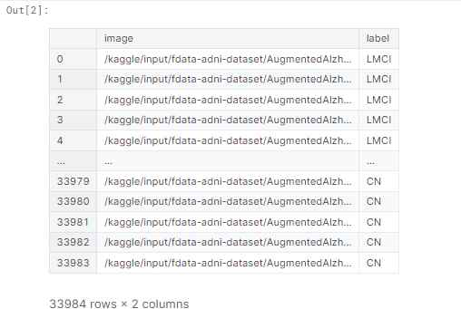

4. Visualization & Analysis of Dataset (data preprocessing)

4.1 Data preprocessing
Data preprocessing is a crucial step in the data analysis and machine learning pipeline. It involves cleaning and transforming raw data into a format that is suitable for analysis or model training. The quality of the data and the effectiveness of subsequent analyses or machine learning models often depend on the success of data preprocessing.

4.2 Visualization
refers to the representation of data or information in a graphical or visual format. The goal of visualization is to present complex data in a way that is easy to understand, allowing for the identification of patterns, trends, and insights. Visualization is a crucial tool in data analysis, scientific research, business intelligence, and various other fields where data-driven decision-making is essential.

4.3 Analyzing a dataset
involves examining and interpreting the data to uncover patterns, trends, relationships, and insights that can inform decision-making or answer specific questions. The analysis process may vary depending on the nature of the data, the objectives of the analysis, and the tools available. Here is a general framework for analyzing a dataset:

-The Number of Samples for Each Class: -
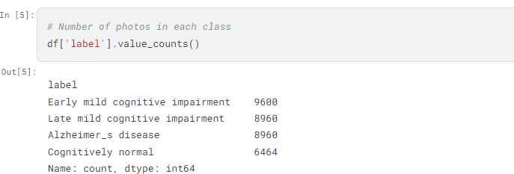
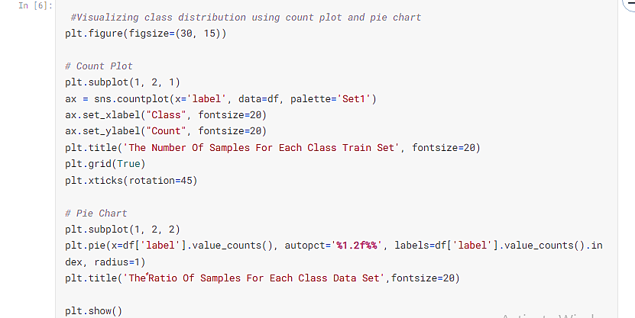

4.4 Split Data
we split data into: -
- 80% train
- 10% test
- 10% validation

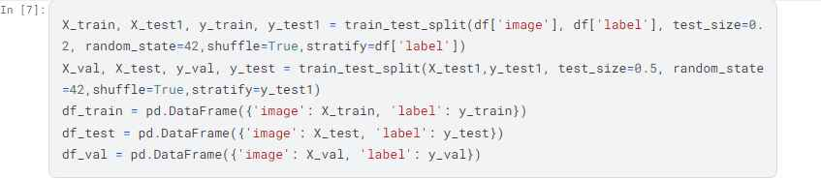

4.4.1 In Train
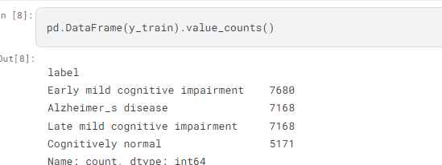

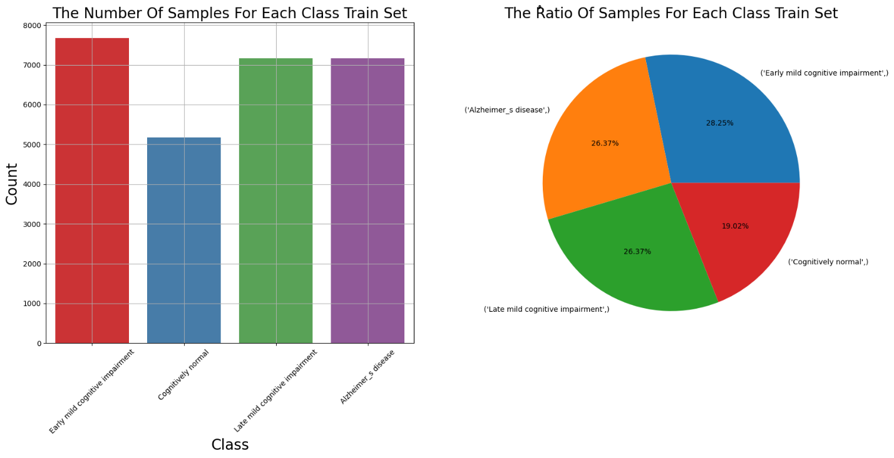
Figure (15) Train Data

4.4.2 In Test
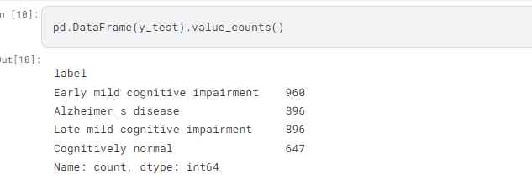

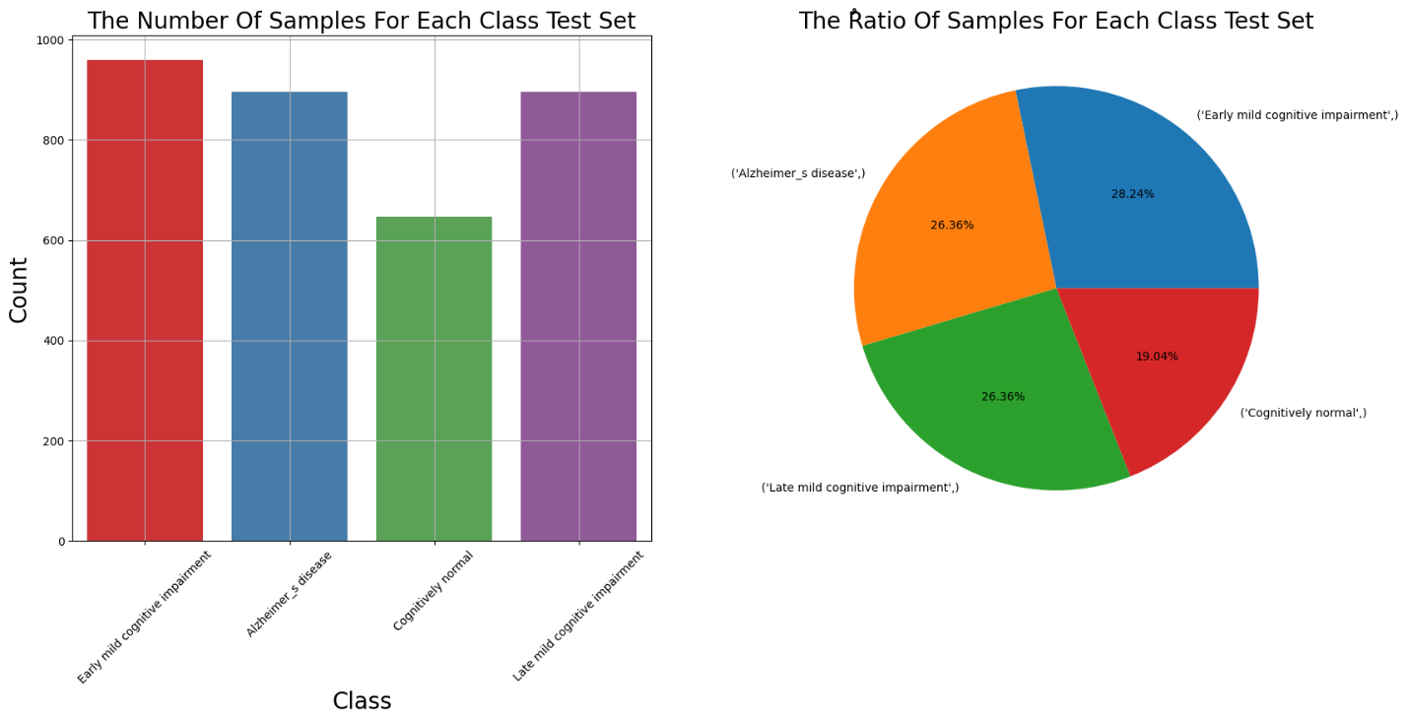
Figure (16) Test Data

4.4.3 In Validation

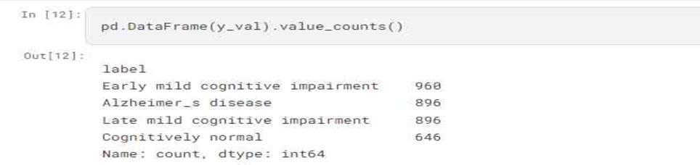
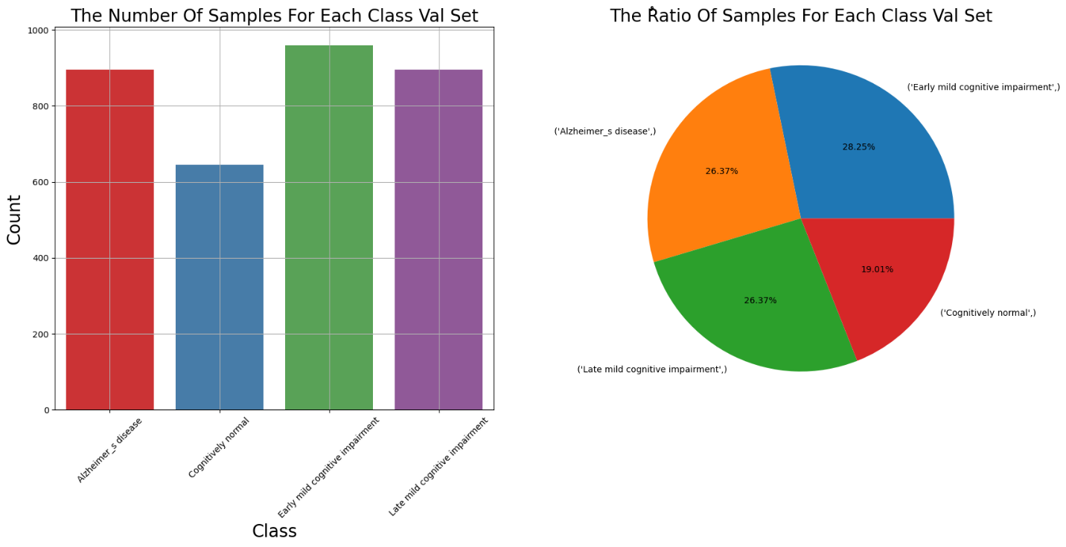
Figure (17) Validation Data

4.5 Data Augmentation
Data augmentation is a technique commonly used in machine learning and deep learning to artificially increase the size of a training dataset by applying various transformations to the existing data. The goal of data augmentation is to diversify the training set, thereby improving the generalization and robustness of a model. This technique is particularly useful in scenarios where the amount of labeled training data is limited. In computer vision tasks, such as image classification, object detection, and segmentation, data augmentation is frequently applied to images. Common image augmentations include:
- Rotation
- Flip (horizontal and vertical)
- Zooming
- Scaling
- Cropping (etc.)
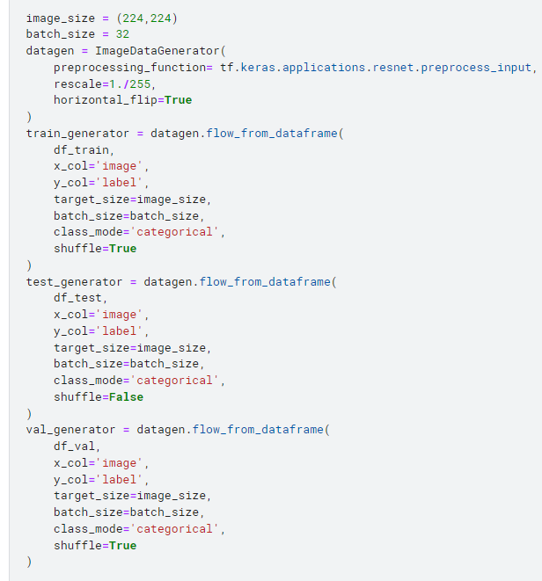

Now we show four classes an image: -
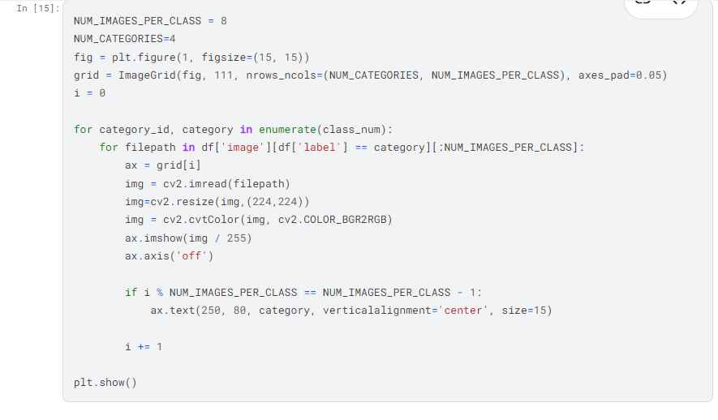

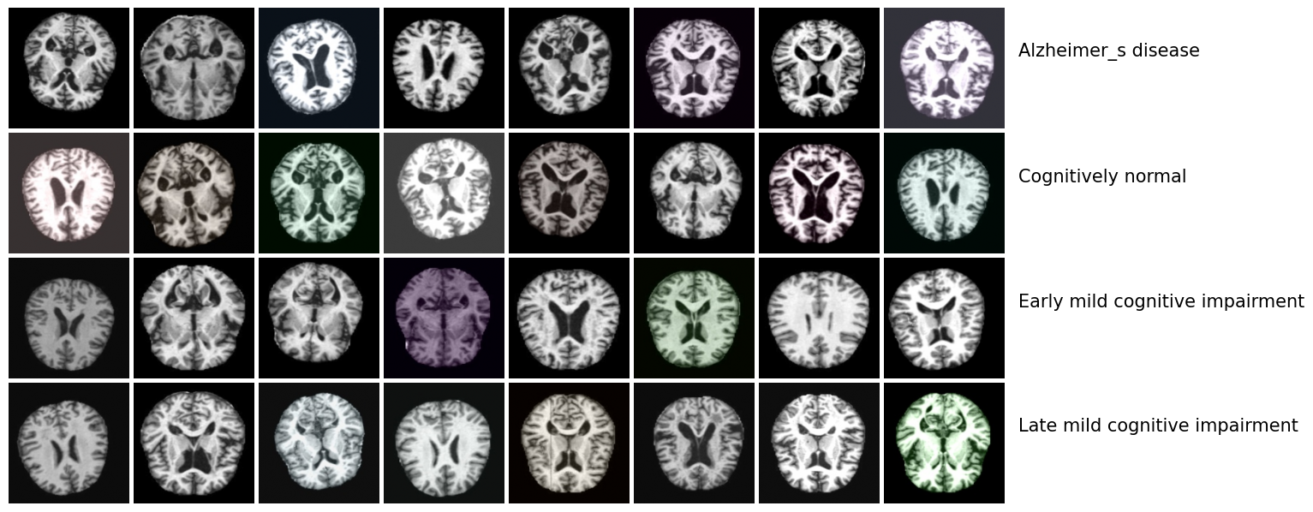

Figure (18) Data Visualization

5. Model training
This content aims at diagnosing some diseases that target humans, which cause him many problems, as can be done by doctors but in order to have time and know the result of the disease in a circumstance where there is no human element expert in that specialty or emergency unintentional circumstances, we use the Convolution model through the application Neural Networks (CNNs) by inserting rays for patients, showing the result, analyzing it, knowing how to deal with the discase, and reviewing some information about it and instructions for it. Devices are used to take images of X-rays for Alzheimer, fields of medicine It is necessary to read and understand these X-rays, and despite the skill that doctors professional, conducting such examinations cost them a lot of time and exhaustion even He can accurately identify the disease, and it is possible to diagnose the disease in a wrong way in some cases due to the presence of some anomalies, This may lead to loss of life due to the delay in the diagnosis of rays and when the examination is completed in time, as the diagnosis includes understanding the image and knowing the location of the injury that was taken using (X-ray, magnetic resonance), but with the progress of science and the field of computers, especially the field of artificial intelligence, we have a field of machine learning with various algorithms, which helped us in many areas and saved us a lot of time and is characterized by high predictive accuracy as well. Like the (ML techniques include decision tree learning, clustering, support vector machines (SVMs), k-means nearest neighbor (K-NN)), but we had a problem with these algorithms, which is that they depend on extracting the distinctive features and these features take a lot of time and effort so that we can identify with high accuracy, especially when we deal with images, as this is cumbersome. Therefore, we used my own algorithms in the field of deep learning, through which we can enter groups of images classified (according to disease) from professional doctors and use some Modern technologies such as convolutional neural networks, which are considered one of the most successful models in the field of image classification, which are based on mathematical algorithms.
Functionality carts detecting functional abnormalities, then knowing its size, location, and shape, and this the specialized doctors carefully understand the captured rays of Alzheimer and know what disease they contain or if they do not contain a disease. This is done by process is carried out in a traditional manner from Before doctors, based on their competence, and this takes a lot of time and effort. Therefore, modern techniques convolutional neural networks (CNN) enable us to perform these tasks very quickly and with high accuracy, and where these tasks are carried out in several steps. Classification of the medical image medical image classification involves identifying and assigning labels to medical images from a fixed set. The task involves extracting features from the image and assigning labels using the extracted feature.
- We Use Four Models
- Convolutional Neural Network (CNN).
- ResNet152V2
- VGG16
- DenseNet201
- MobileNetV2

5.1 CNN
A convolutional neural network (CNN) is a powerful type of deep learning for image processing often used in computer vision that includes image and video recognition. CNN consists of a set of layers, namely, the input layer, the output layer, and a hidden layer consisting of multiple convolutional layers, pooling layers, and fully connected layers. These layers will be explained in the following:
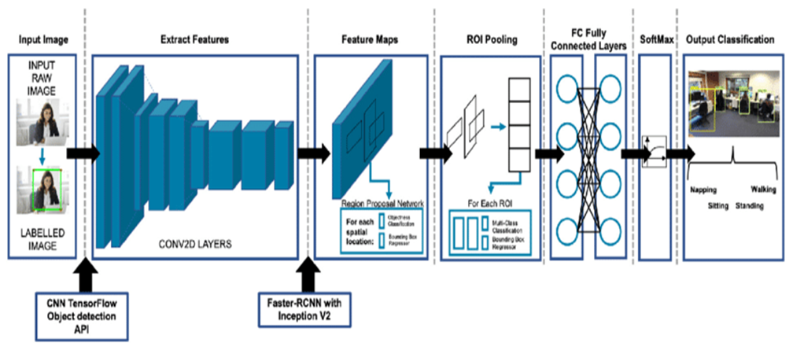

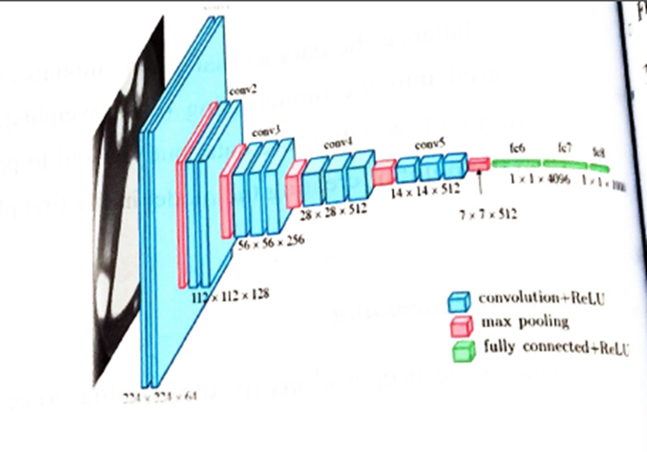

Figure (19) CNN Model

5.1.1 CNN build steps
- Using Keres Libraries
  - Initialize the CNN
  - Add a convolutional layer.
  - Pooling operation
  - Add more convolutional layers.
  - Flattening operation
  - Fully connected layer
  - Output layer (SoftMax)

5.1.1.1 Initialize the CNN
Model =Sequential ()
We first need to initiate sequential class since there are various layers to build CNN which all must be in sequence.

5.1.1.2 Add a convolutional layer.
Model. Add (Conv2D (filters, kernel _size.
Activation = "Relu".
input _shape= input_ shape,
strides = (1. 1).
Padding ="Same"))

5.1.1.2.1 Filters
The primary purpose of convolution is to find features in the image using a feature detector. Then put them into a feature map, which preserves distinct features of images. Feature detector which is known as a filter also is initialized randomly and then after a lot of iteration, filter matrix parameter selected which will be best for separating images. For instance, animals' eyes, noses, etc. will be considered as a feature which is used for classifying images using filter or feature detectors.

5.1.1.2.1.1 Kernel Size
• Kernel Size refers to filter (f*f) matrix size.

5.1.1.2.2 Padding ("valid" or "same")
"valid" means no padding ("same" results) -- default parameter.
"same" add constant value to the left/right or up/down of the input (size output = size input) image.

5.1.1.2.3 Strides
An integer or tuple of 2 integers, specifying the strides of the convolution along the height and width.

5.1.1.2.4 Activation Function
Rectified linear activation function (Relu)
Relu function will output the input directly if it is positive, otherwise, it will output zero.
f(x)=max (0, x)

5.1.1.2.5 Input Shape
This argument shows image size (n*m*d). Since the images are in RGB format so, the third dimension of the image is d (d like 1 or 3).

5.1.1.3 Pooling Operation
Model. add (Max Pooling21) (pool size (2, 2)))
The pooling layer is used to reduce the dimensions of the feature maps, it is an operation of sampling of the image.
Max Pooling: Calculate the maximum value for each patch of the feature map.
Average Pooling: Calculate the average value for each patch on the feature map.

5.1.1.4 Add More Convolutional Layers
To add more convolutional layers, we need to repeat steps 2 &3 with modification in the number of filters.

5.1.1.5 Flattening Operation
Model. add (Flatten ())
Is converting the dataset into a 1-D array for input into the next layer which is the fully connected layer.

5.1.1.6 Fully Connected Layer
Model. add (Dense (n, activation="Relu"))

5.1.1.7 Output Layer (SoftMax)
It is used as the last activation function of a neural network to bring the output of the neural network to a probability distribution over predicting classes.
The probabilities sum should be one for all possible predicting classes.

5.1.2 Model Architecture.
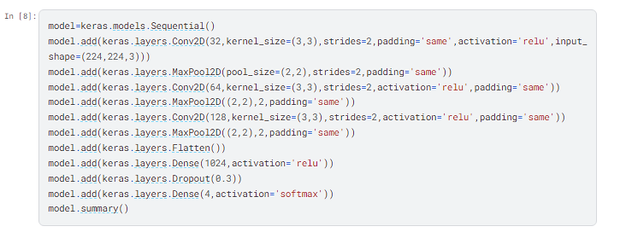

5.1.3 Model Scratch.
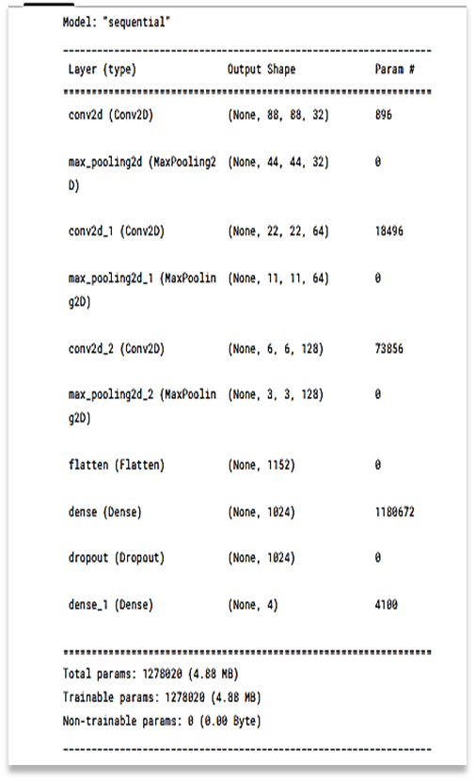
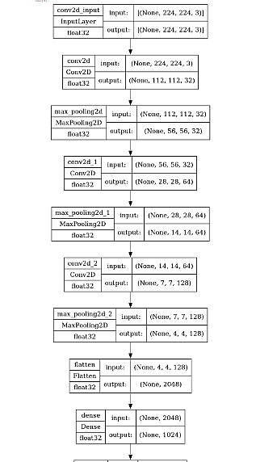

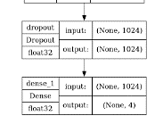

Figure (20) CNN Model Scratch

5.1.4 Training the model
Now, let's discuss training and evaluation of the Convolutional neural network. We will be discussing this section in 3 steps:
- The Compile models.
- Fit model on training set
- Evaluate Result

5.1.4.1 The Compile models.
Model. Compile (loss='categorical _cross entropy',
Optimizer='Adam’, metrics=['accuracy'])
• Here we are using 3 arguments

1. Loss function
We are using the categorical cross entropy loss function that is used in the classification task.

2. Optimizer
We are using Adam Optimizer that is used to update neural network weights and learning rate.
Optimizers are used to solve optimization problems by minimizing the function.

3. Metrics
We are using Accuracy as a metric to evaluate the performance of the CNN Model.

5.1.4.2 Fit model on training set
Model. fit _generator = (training_ set, validation_ data= test _set, epochs =n, steps _per _epoch= m,validation_ steps= v).
We are fitting the CNN model on the training dataset with n iterations and each iteration has different (m) for training and evaluating (v) steps based on the length of the test and training set.

5.1.4.3 Evaluate Result
Model. evaluate ("Test _generator')
Then we evaluate the model based on the test dataset.

5.1.5 Model Performance
We have 50 Epoch.
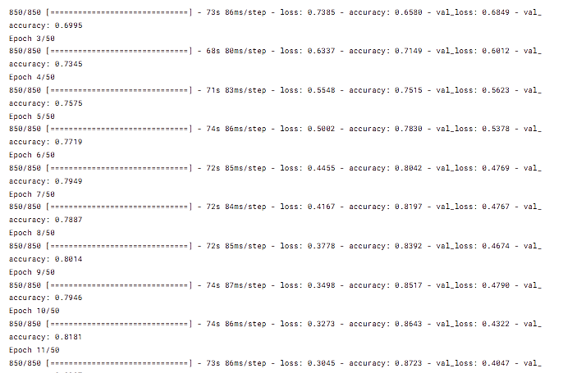

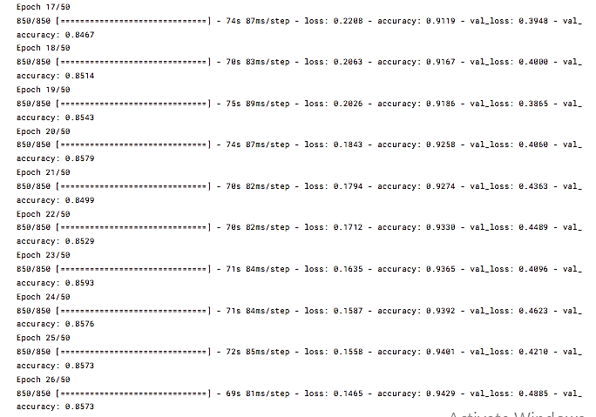

5.1.6 Evaluate the Model
Evaluating a model refers to the process of assessing its performance and effectiveness in making predictions or classifications on new, unseen data. The goal is to understand how well the model generalizes to data it has not been trained on, as the ultimate objective of a machine learning model is to make accurate predictions on new, real-world examples.
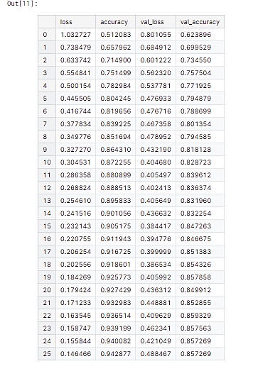

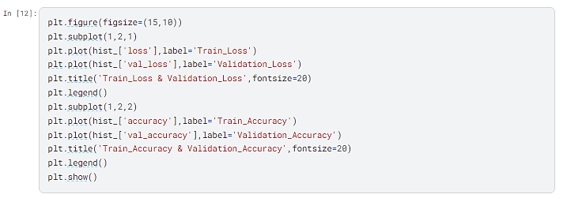
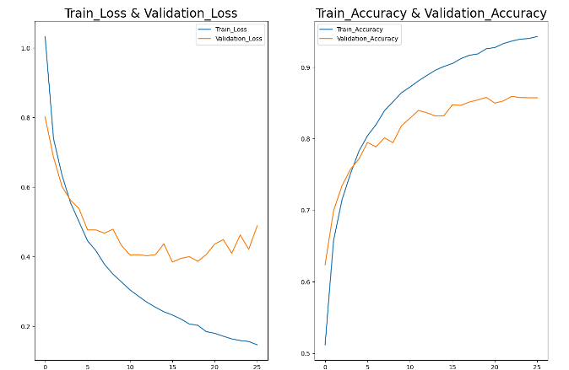
Figure (21) CNN Evaluation

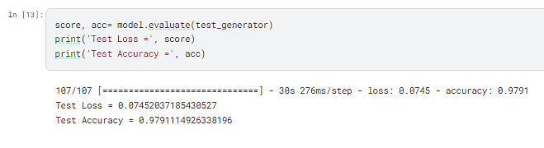
5.1.7 Model score

5.1.8 Model predictions
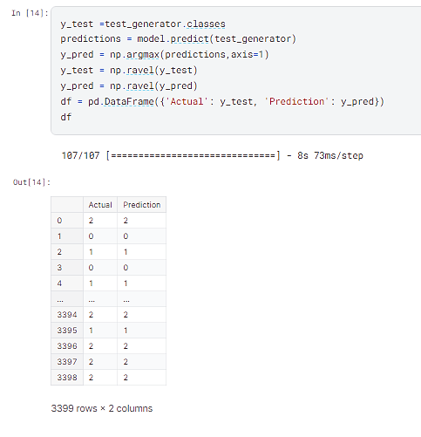

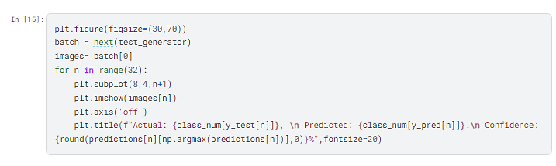

Figure (22) CNN Prediction

5.1.9 Model Evaluation

5.1.9.1 Confusion Matrix
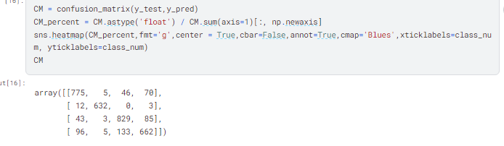

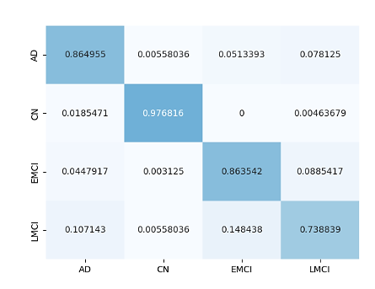

Figure (23) CNN Confusion Matrix

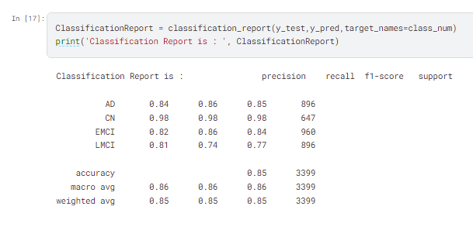
5.1.9.2 Classification Report

5.2 VGG16
The VGG-16 model in machine learning refers to convolutional.
neural network (CNN) architecture that was proposed by the Visual Geometry Group (VGG) at the University of Oxford. It was introduced in the paper titled "Very Deep Convolutional Networks for Large-Scale Image Recognition" by Karen Simonyan and Andrew Zisserman in 2014.

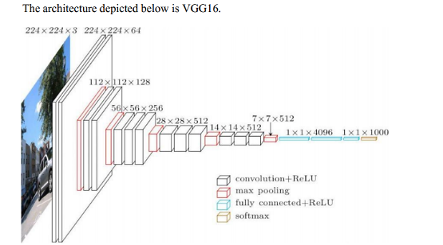

Figure (24) VGG16 Model

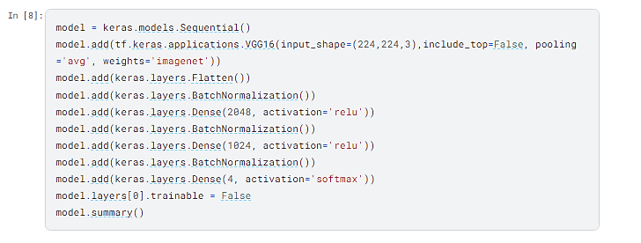
5.2.1 Model Architecture

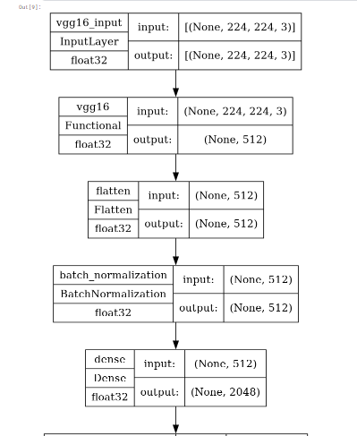
5.2.2 Model Scratch
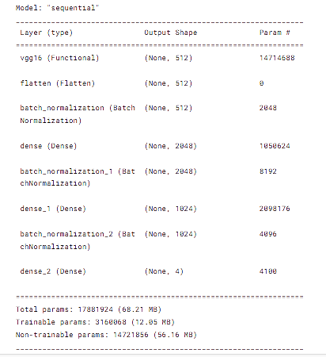

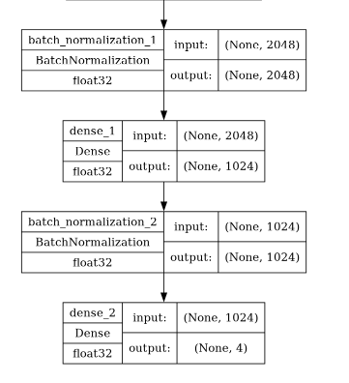

Figure (25) VGG16 Model Scratch

5.2.3 Evaluate the Model
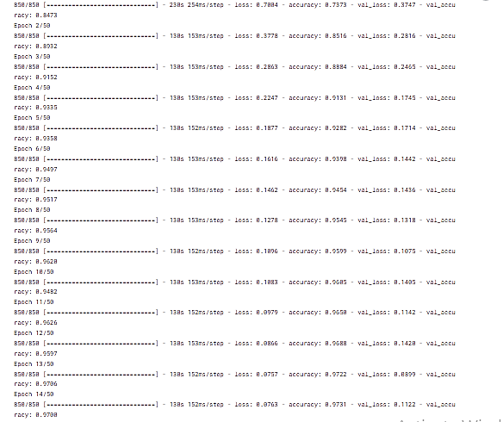

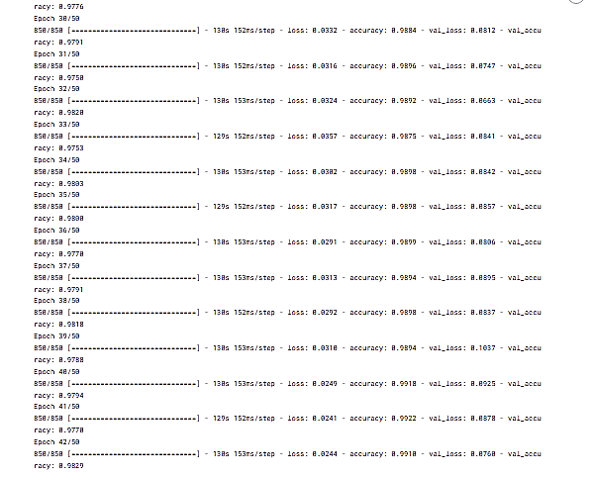

5.2.4 Evaluate the Model
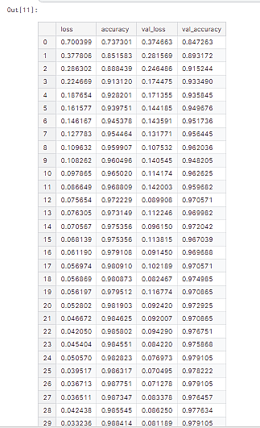

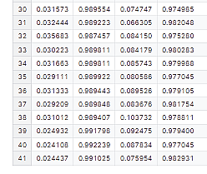

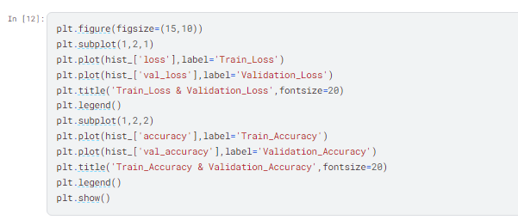
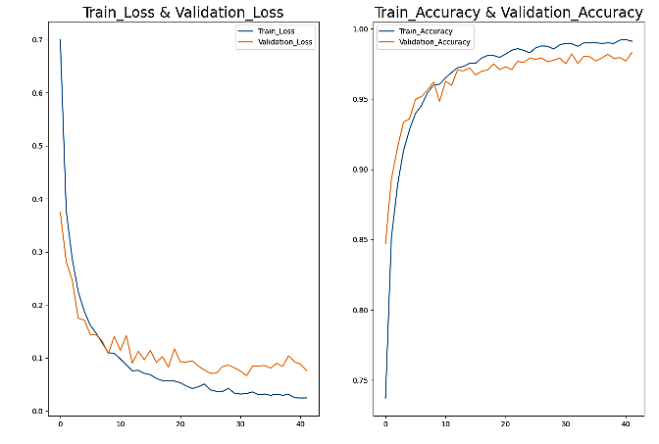
Figure (26) VGG16 Evaluation

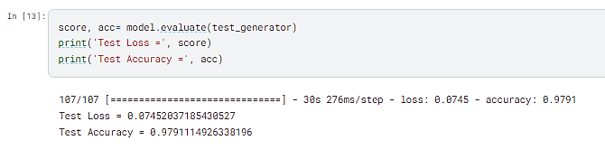
5.2.5 Model Score

5.2.6 Model Predictions
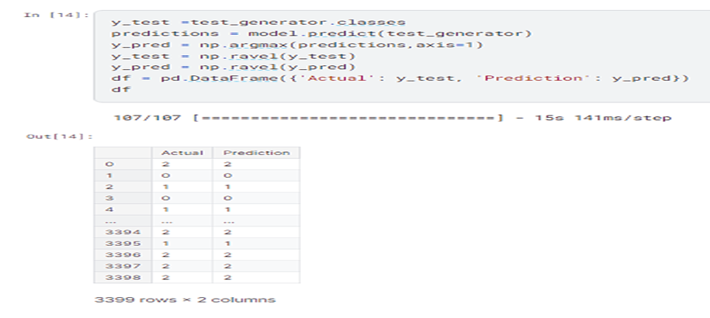
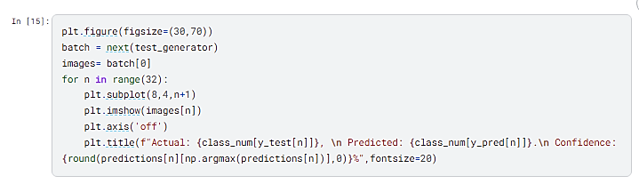

Figure (27) VGG16 Prediction

5.2.7 Model Evaluation

5.2.7.1 Confusion Matrix
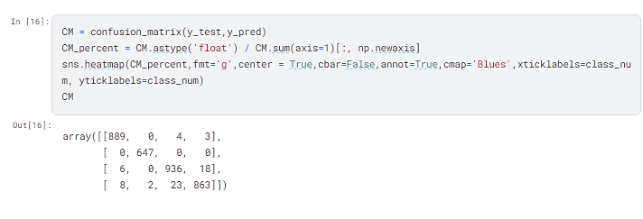

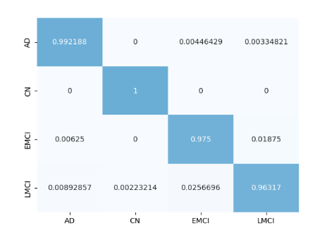

Figure (28) VGG16 Confusion Matrix

5.2.7.2 Classification Report
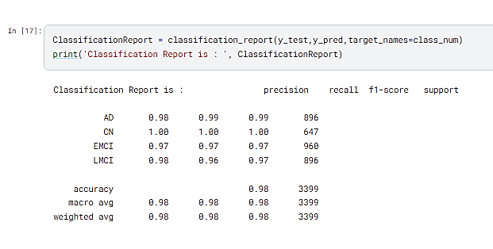

5.3 DenseNet201
DenseNet-201 is a convolutional neural network that is 201 layers deep and is a flexible architecture applicable to a variety of computer vision applications including picture classification, object identification, and semantic segmentation. Among the most prevalent uses of DenseNet are NLP: Used in translation, sentiment analysis, and text generation.
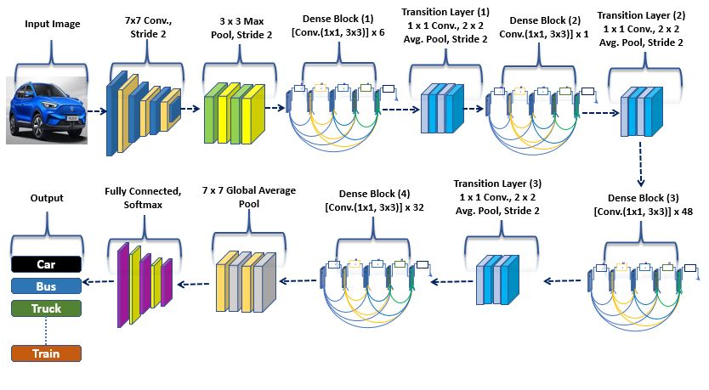
Figure (29) DenseNet201 Model

5.3.1 Model Architecture
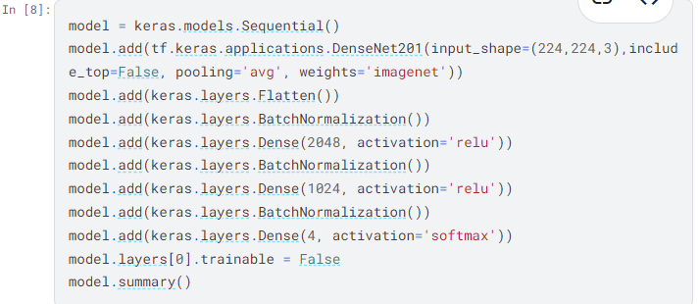

5.3.2 Model Scratch
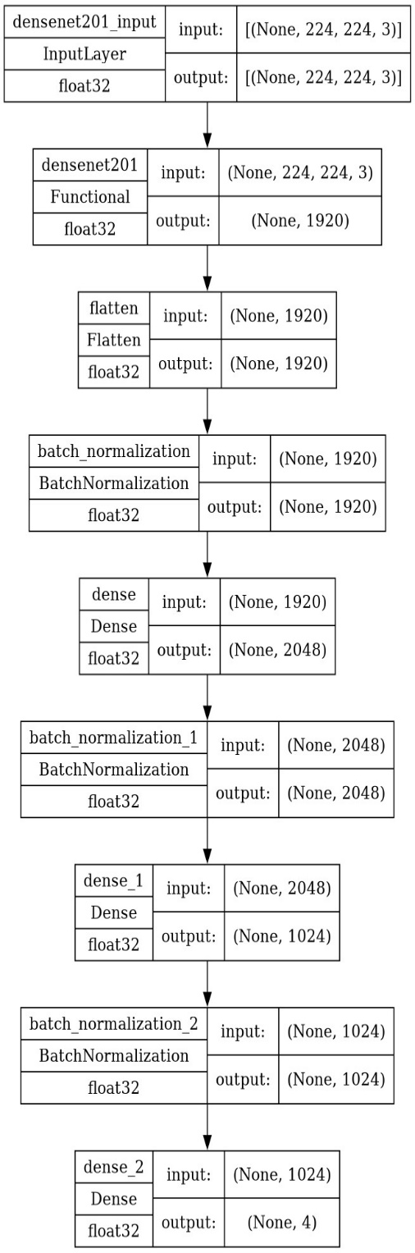
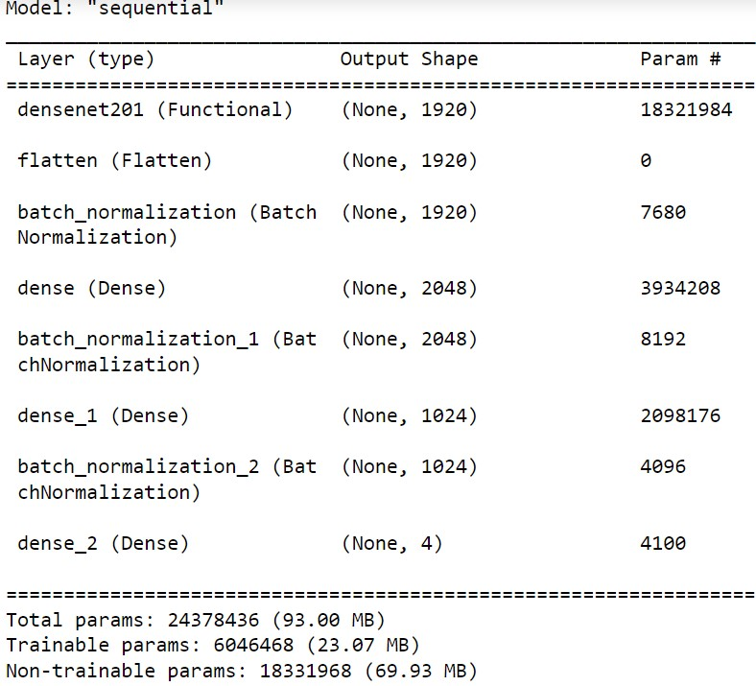
Figure (30) DenseNet201 Model Scratch

5.3.3 Model Performance
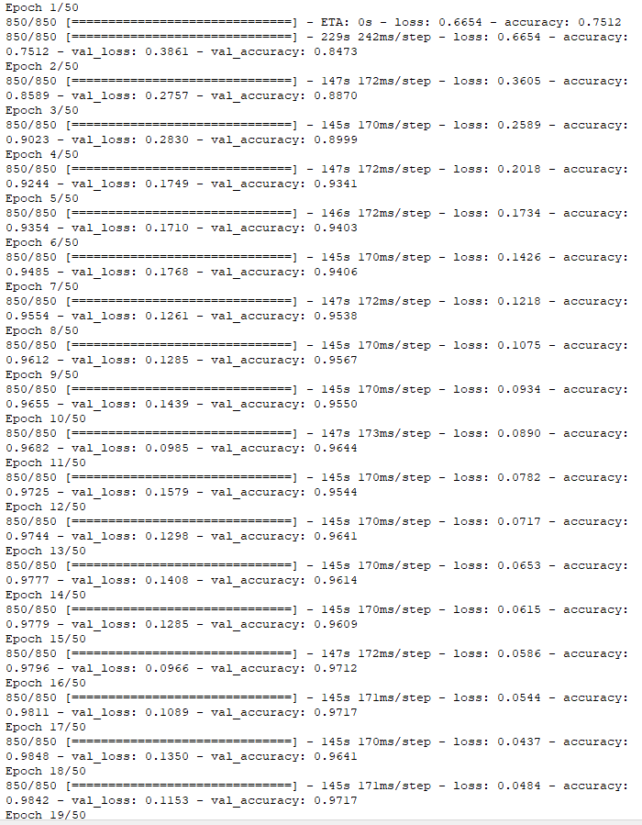
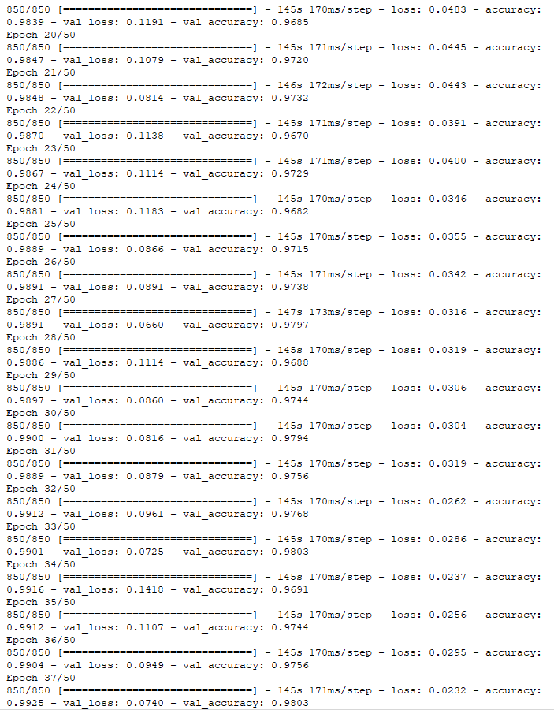

5.3.4 Evaluate the Model
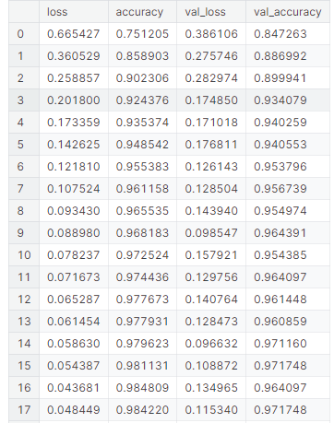
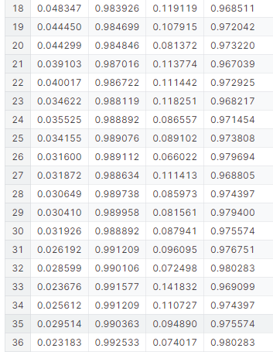
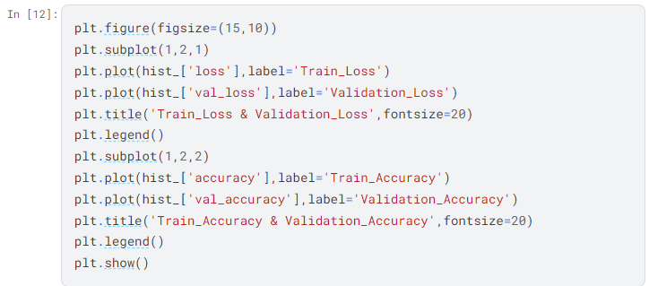
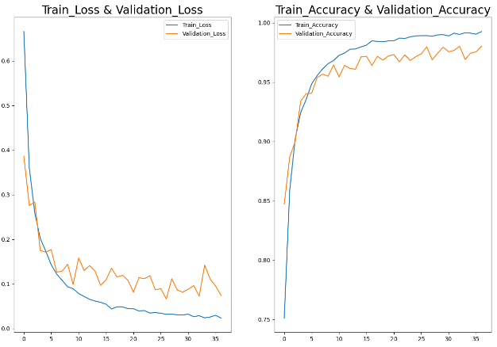
Figure (31) DenseNet201 Evaluation

5.3.5 Model Score
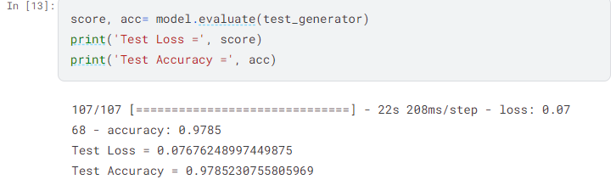

5.3.6 Model Predictions
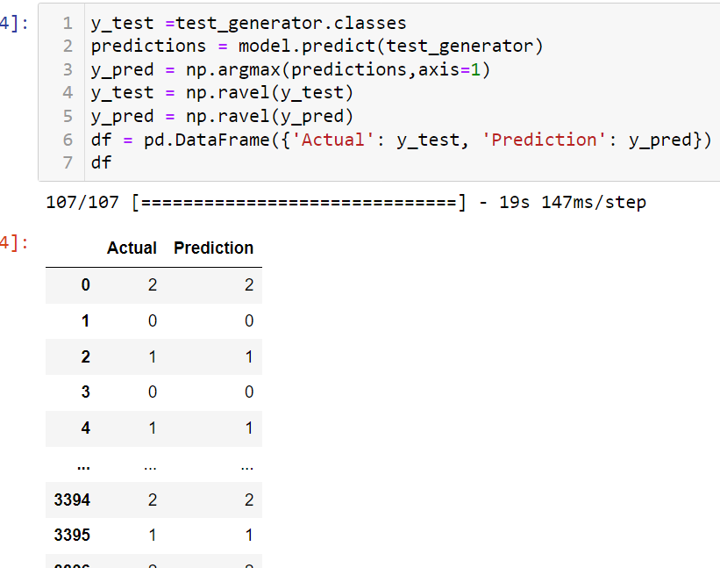
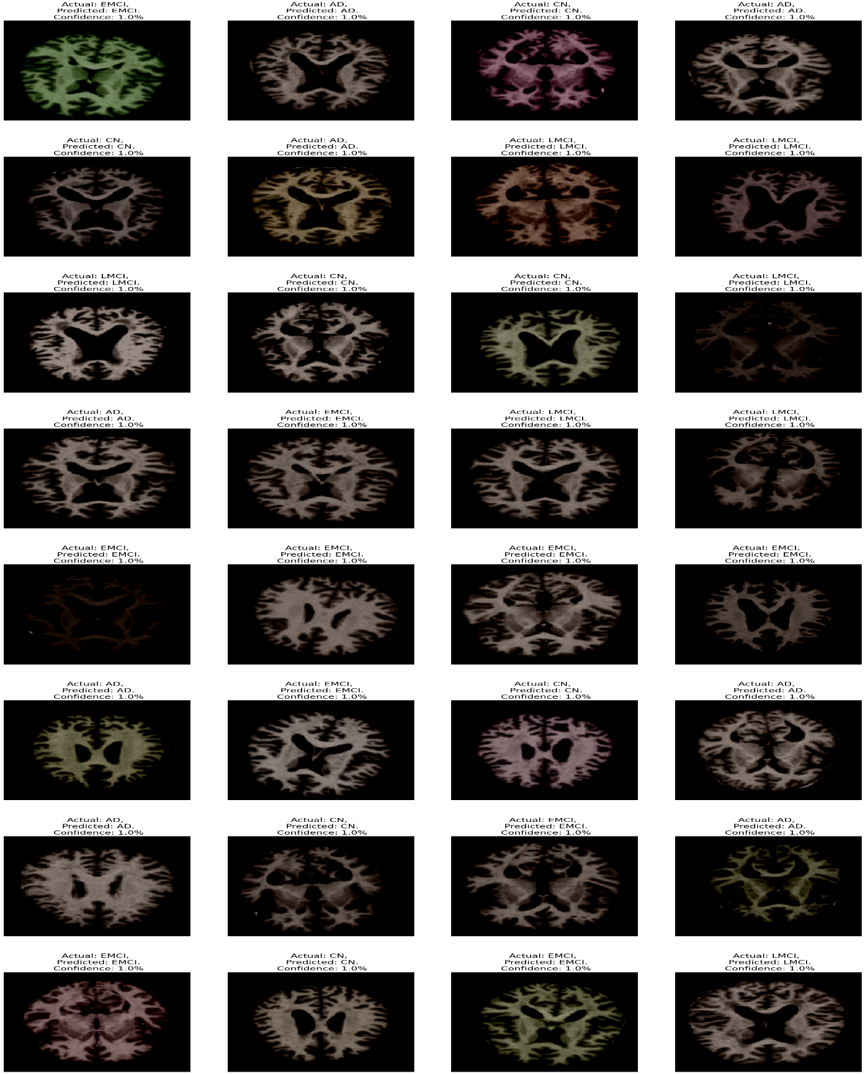

Figure (32) DenseNet201 Prediction

5.3.7 Model Evaluation

5.3.7.1 Confusion Matrix
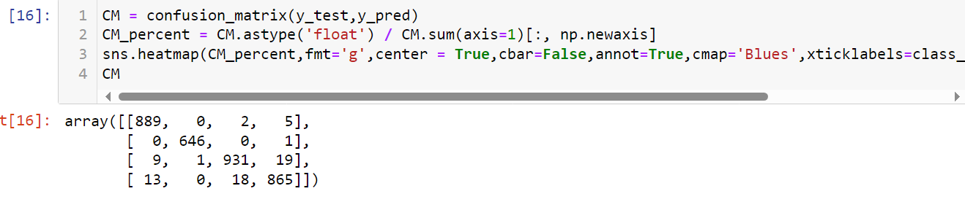

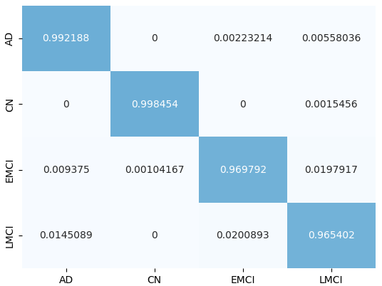

Figure (33) DenseNet201 Confusion Matrix

5.3.7.2 Classification Report

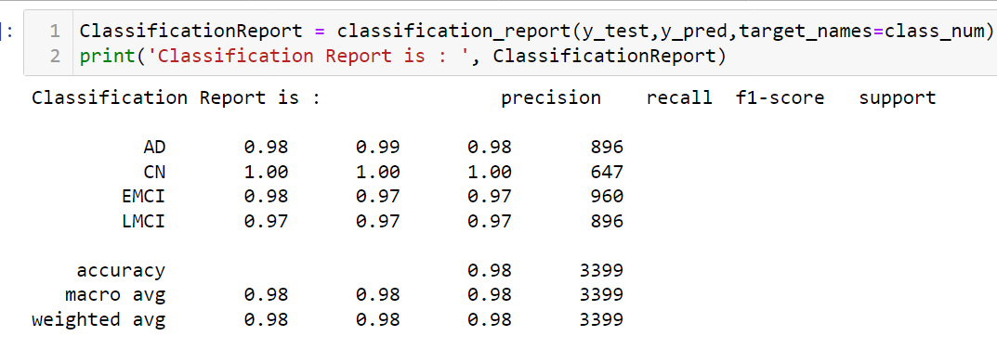

5.4 ResNet152V2
ResNet-v2 is a convolutional neural architecture that builds on the Inception family of architectures but incorporates residual connections (replacing the filter concatenation stage of the Inception architecture). Source: Inception-v4, Inception-ResNet and the Impact of Residual Connections on Learning.

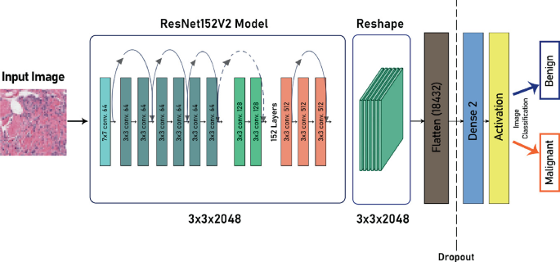
Figure (34) ResNet152V2 Model

5.4.1 Model Architecture
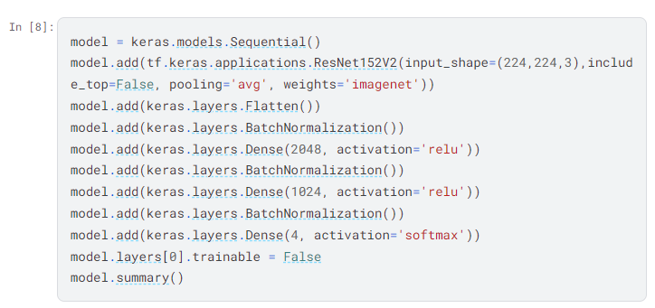

5.4.2 Model Scratch

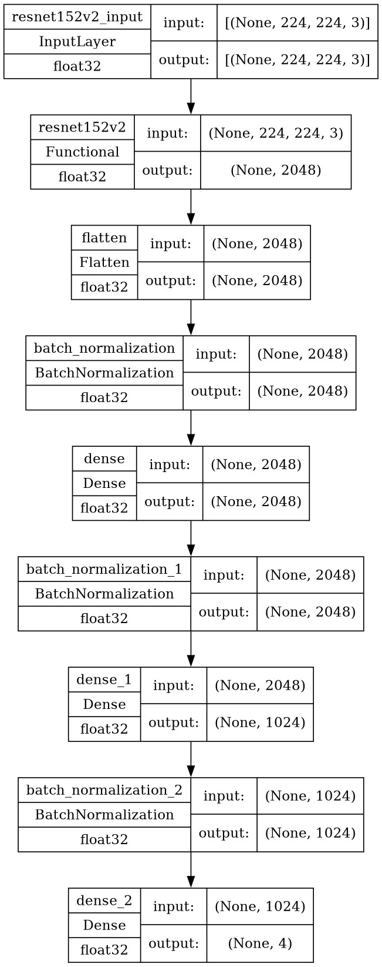
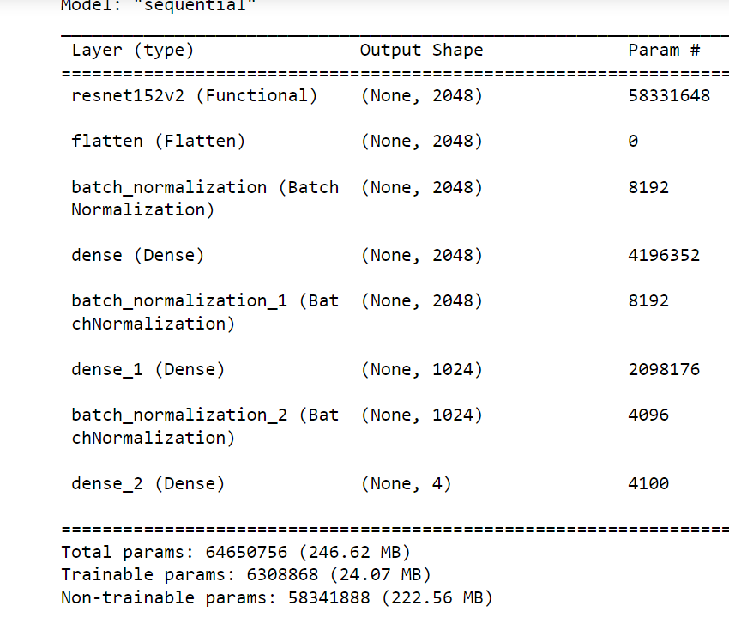

Figure (35) ResNet152V2 Model Scratch

5.4.3 Model Performance

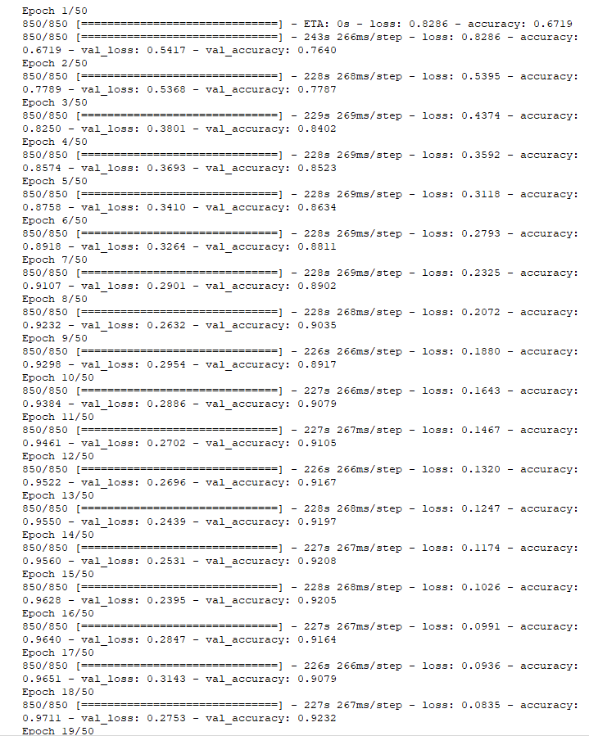
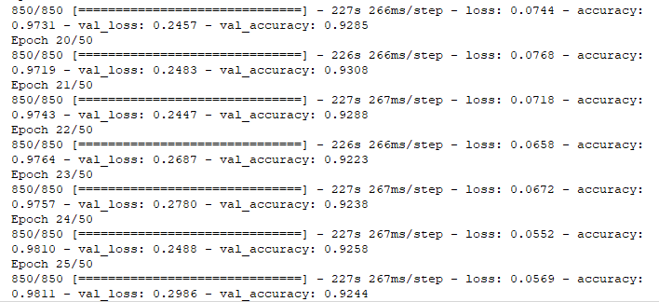

5.4.4 Evaluate the Model

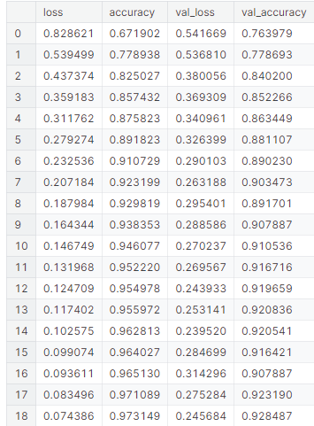
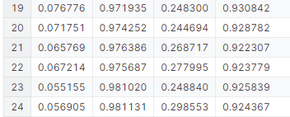

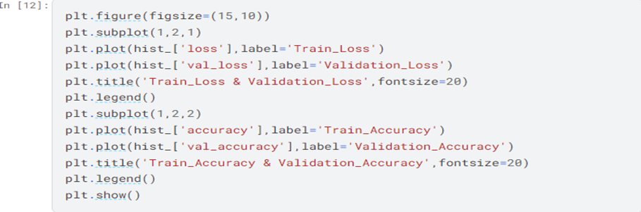

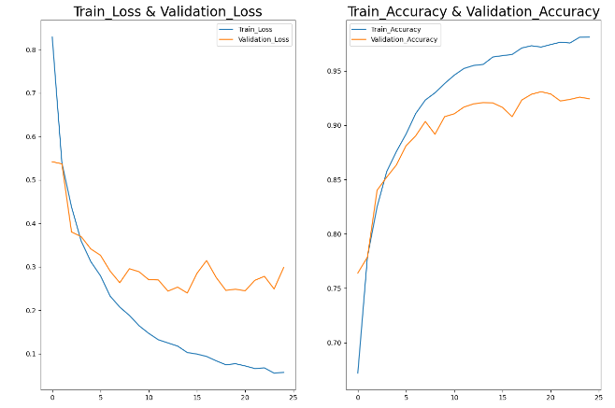
Figure (36) ResNet152V2 Evaluation

5.4.5 Model Score
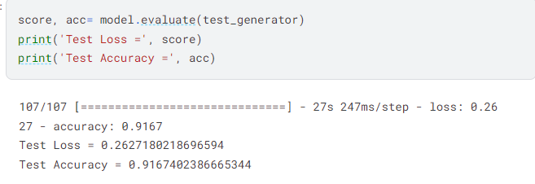

5.4.6 Model Predictions

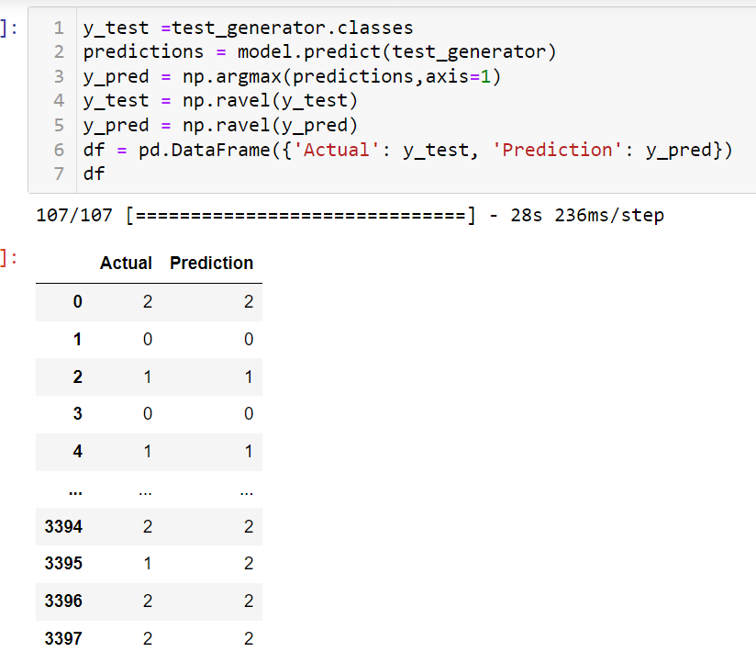
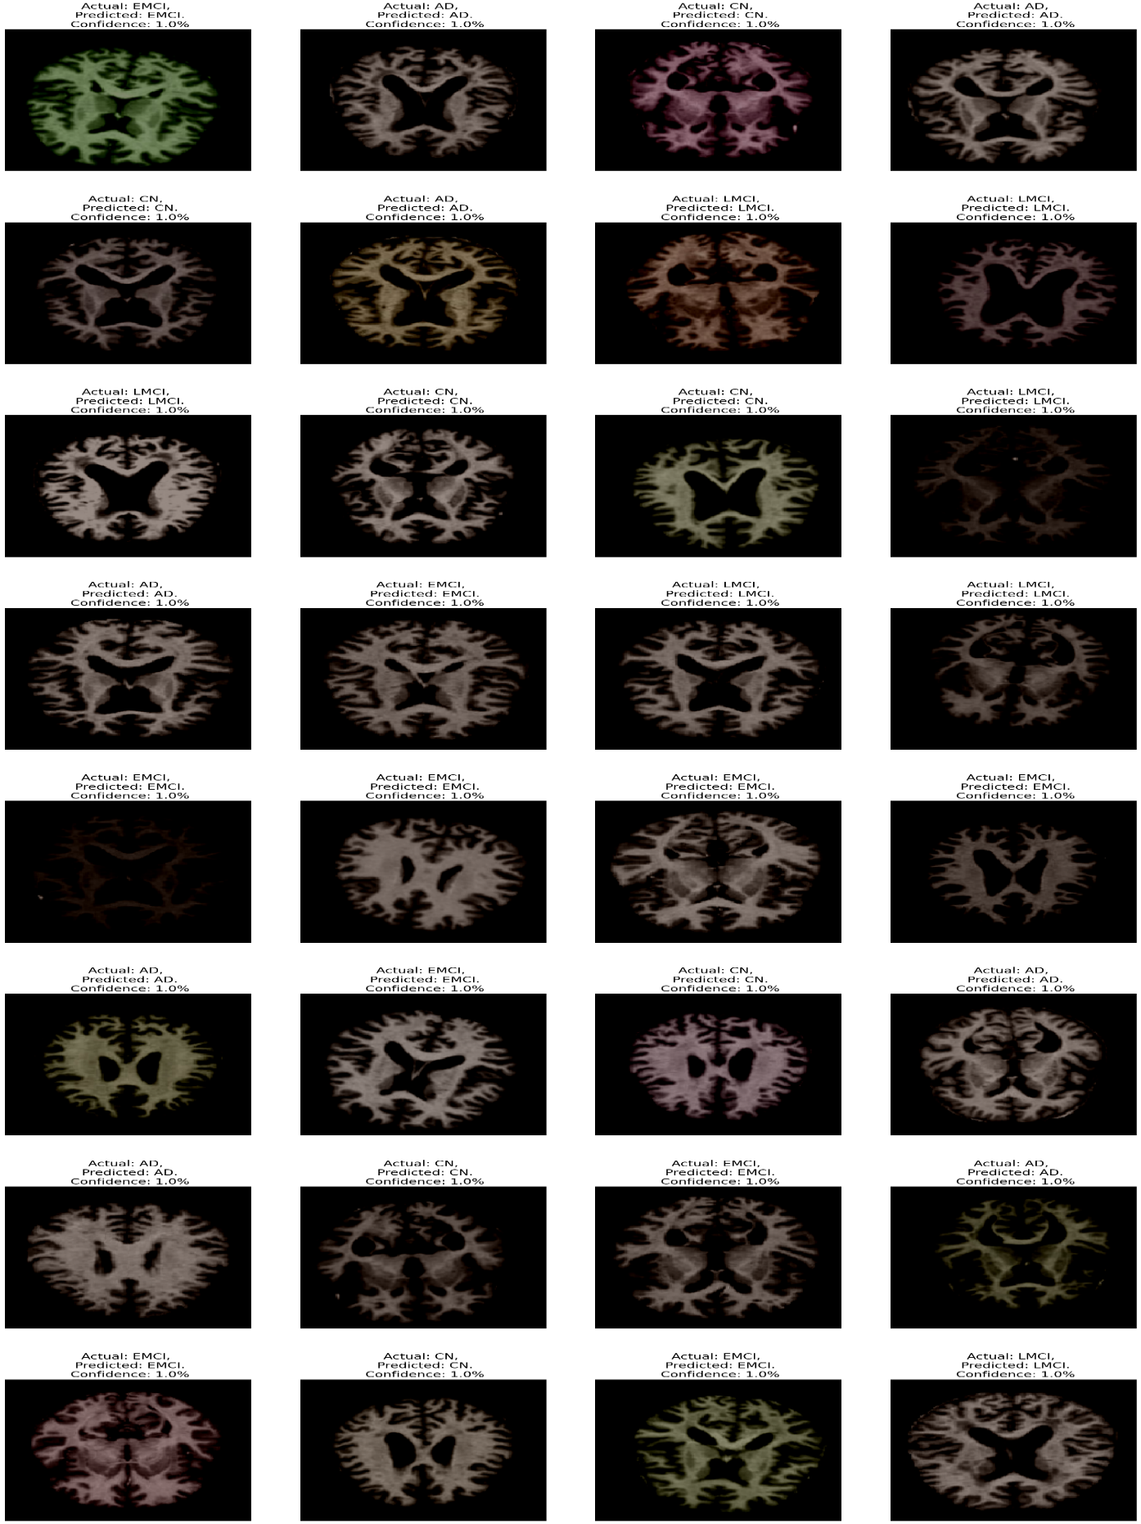
Figure (37) ResNet152V2 Prediction

5.4.7 Model Evaluation

5.4.7.1 Confusion Matrix
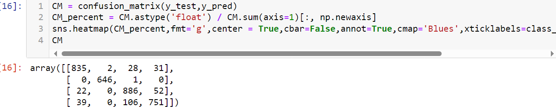
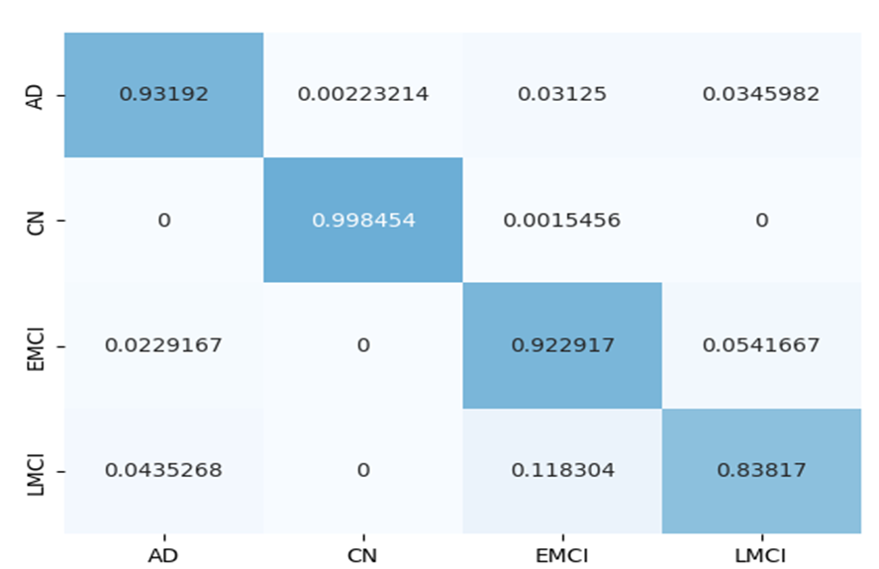
Figure (38) ResNet152V2 Confusion Matrix

5.4.7.2 Classification Report
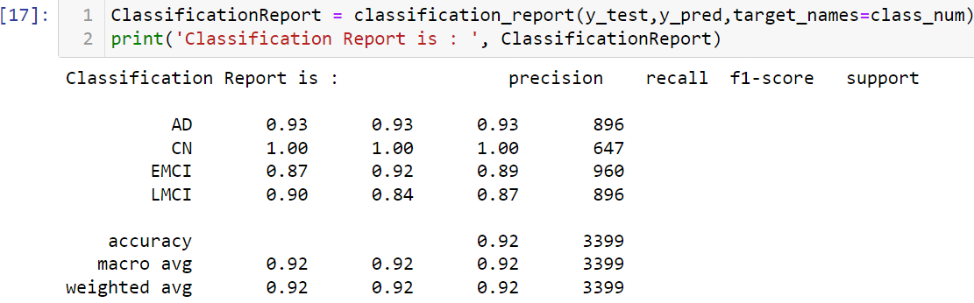

5.5 MobileNetV2
MobileNetV2 is a deep learning model designed for computer vision tasks on mobile devices such as smartphones and tablets. It is an improvement over the original MobileNet model and was developed by researchers at Google. MobileNetV2 aims to enhance model efficiency so that it can run efficiently on resource-constrained devices like mobile phones without sacrificing performance or accuracy. It relies on the idea of using repeated building blocks for construction, making it robust and suitable for a variety of computer vision applications on resource-limited devices.
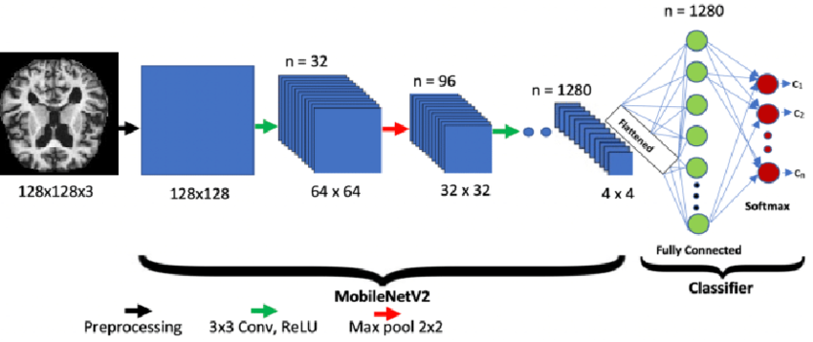
Figure (39) MobileNetV2 Model

5.5.1 Model Architecture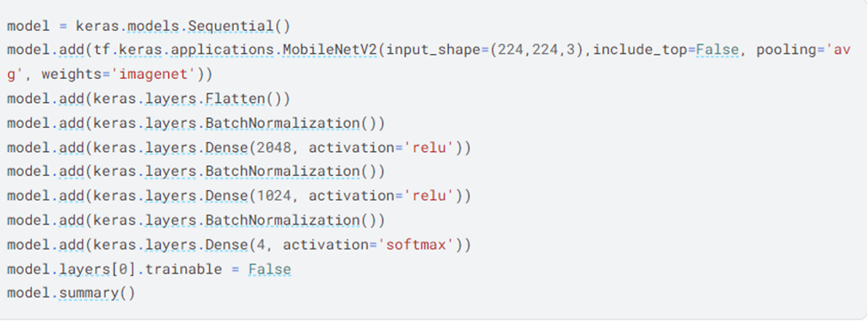

5.5.2 Model Scratch
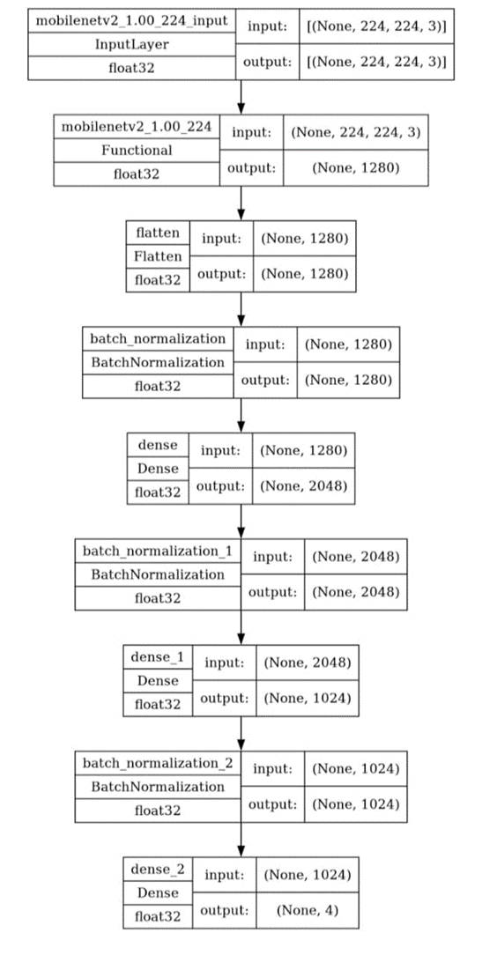
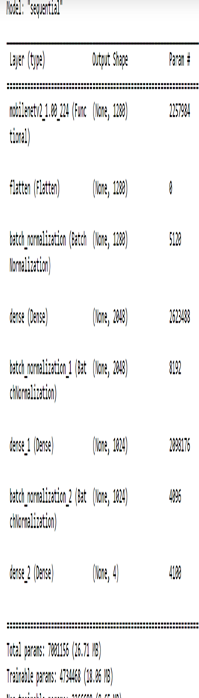
Figure (40) Model Scratch

5.5.3 Model Performance
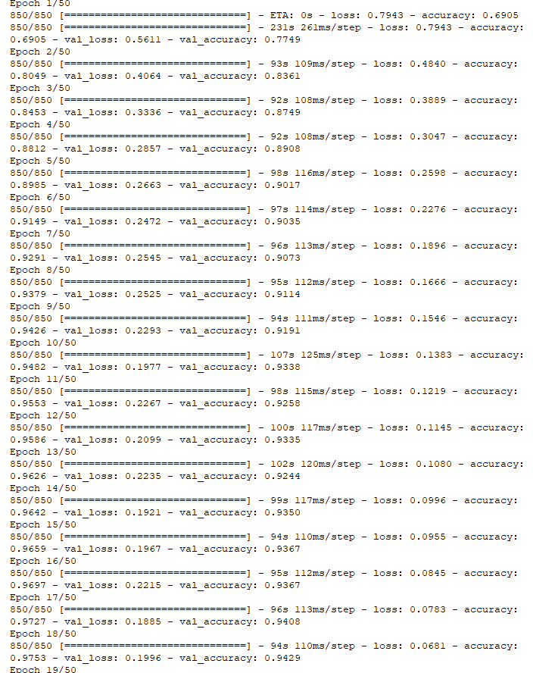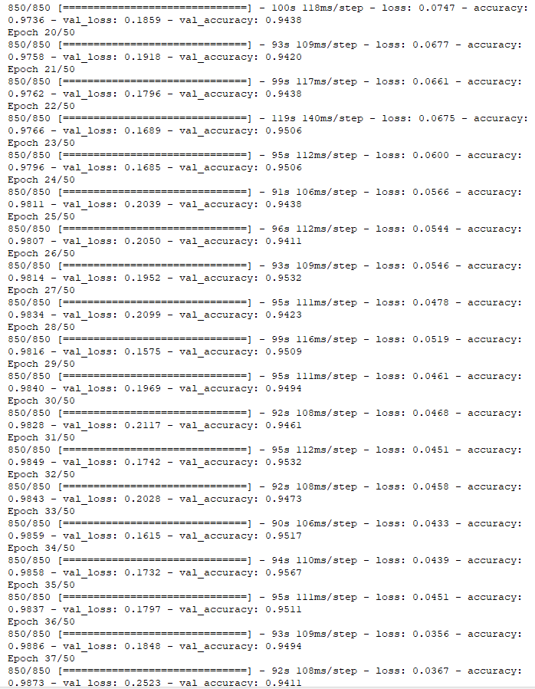

5.5.4 Evaluate the Model
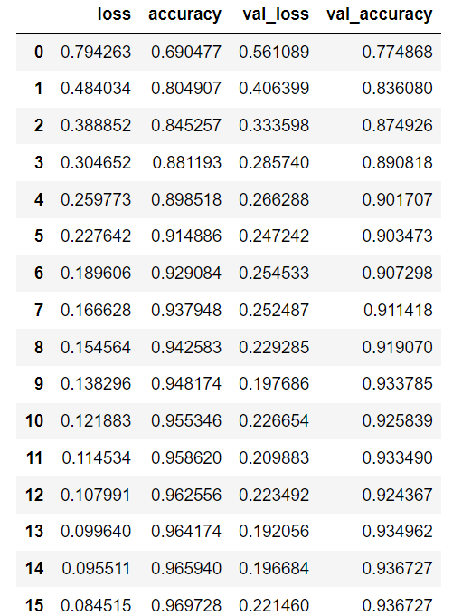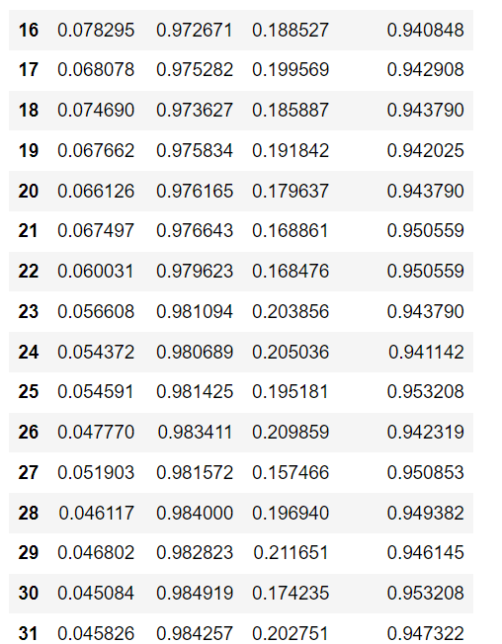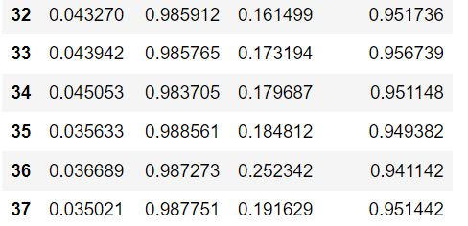
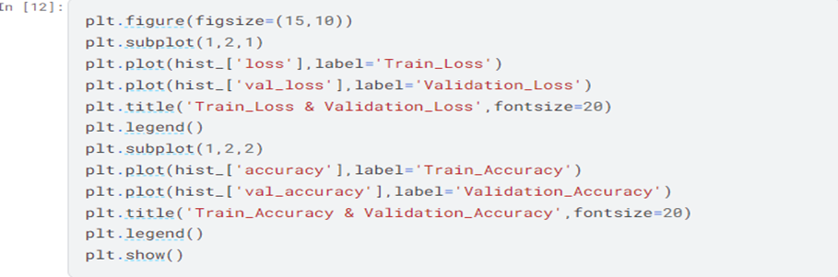

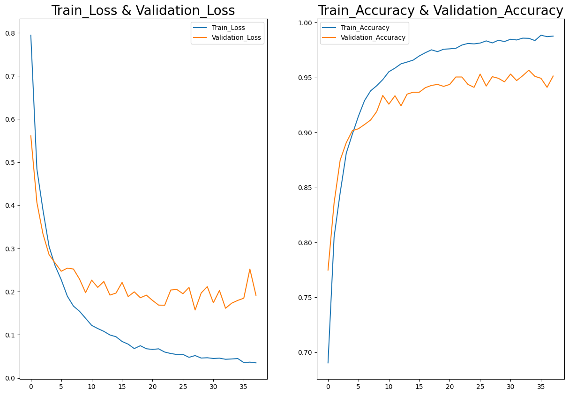
Figure (41) MobileNetV2 Evaluation

5.5.5 Model Score
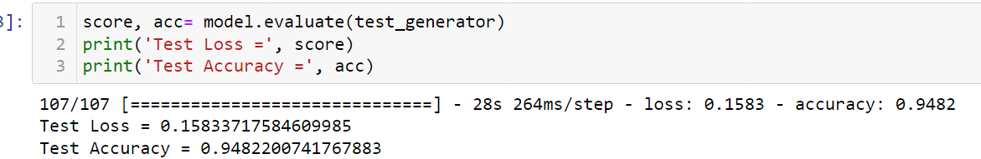

5.5.6 Model Predictions
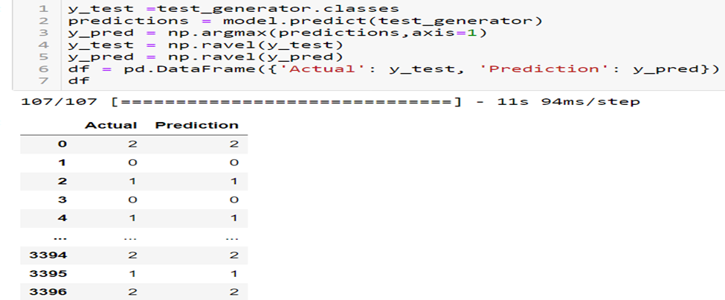
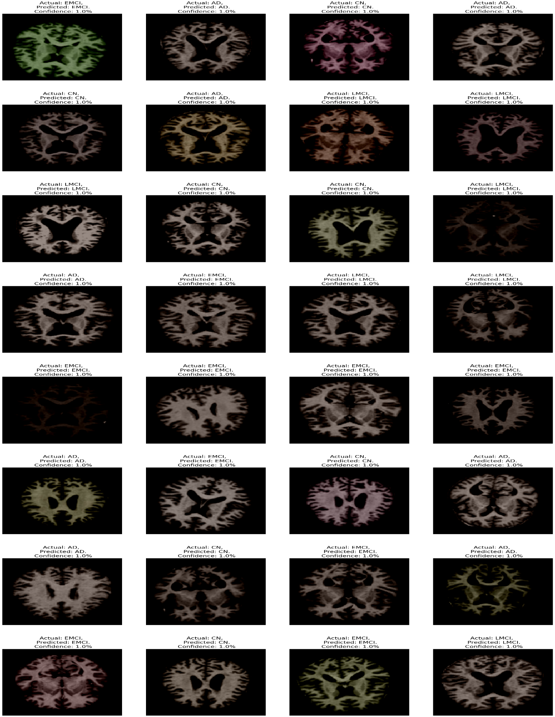
Figure (42) MobileNetV2 Prediction

5.4.7 Model Evaluation

5.5.7.1 Confusion Matrix
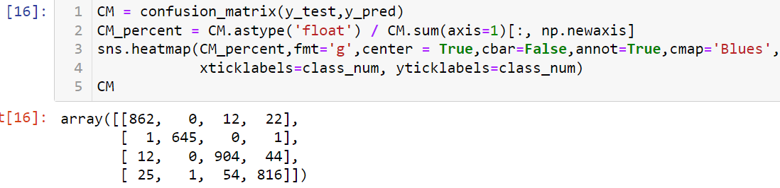
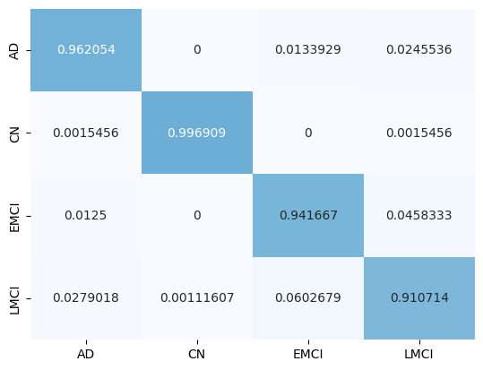
Figure (43) MobileNetV2 Confusion Matrix

5.5.7.2 Classification Report
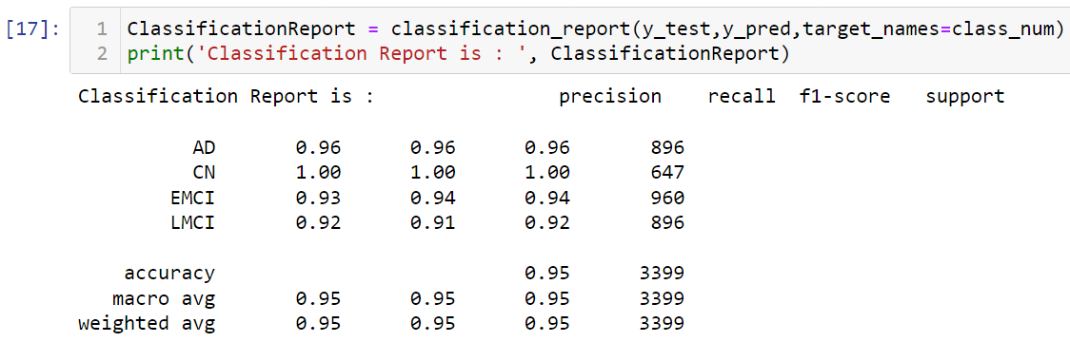

5.6 Summary
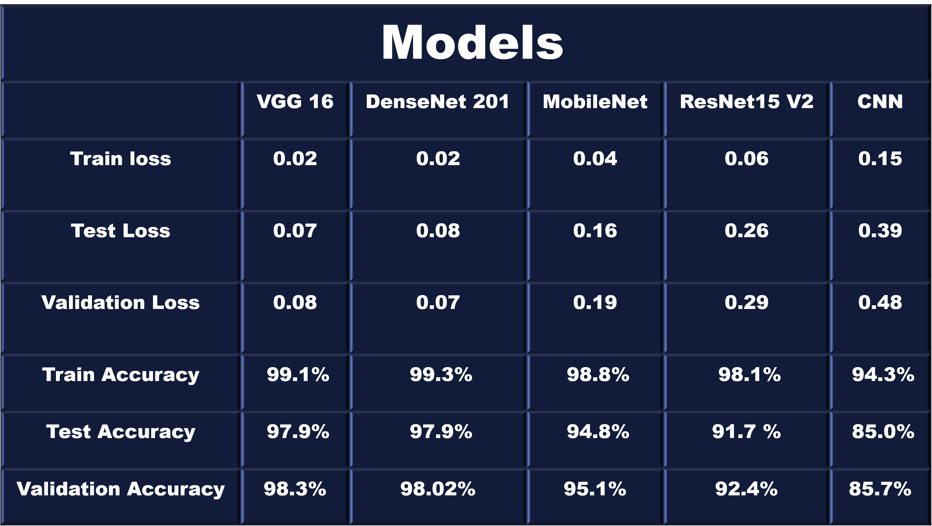
Figure (44) Models Summary

